Sensemaking Moment Analysis: Rutgers Group 2

Overall CEU scoring table, heat map, and CEU graph

Ratings | (excluding n/a)
Coherence | 2.9
Engagement | 2.9
Usefulness | 3.0
Overall | 2.9

C
E
U
 | 1 | 2 | 3 | 4 | 5 | 6 | 7 | 8 | 9 | 10 | 11 | 12 | 13 | 14 | 15 | 16 | 17 | 18 | 19 | 20 | 21 | 22 | 23 | 24 | 25 | 26 | 27 | 28 | 29 | 30 | 31 | 32 | 33 | 34 | 35 | 36

Overall scoring and heat map for Ames Group 4

Looking at the whole-session scores, the Overall score is very high,with a couple of minor and temporary dips in Coherence and Engagement as the mapper caught up with some manipulation issues. For this session, there were no major sensemaking challenges or obstacles, the analysis will focus on the period in timeslots 21 through 27 when the second activity was getting underway and there were some swerves in the otherwise direct/planned intended proceedings.

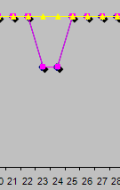
CEU Graph for sensemaking episode

The full CEU grid provides further detail on what occurred and the CEU ratings in each timeslot:

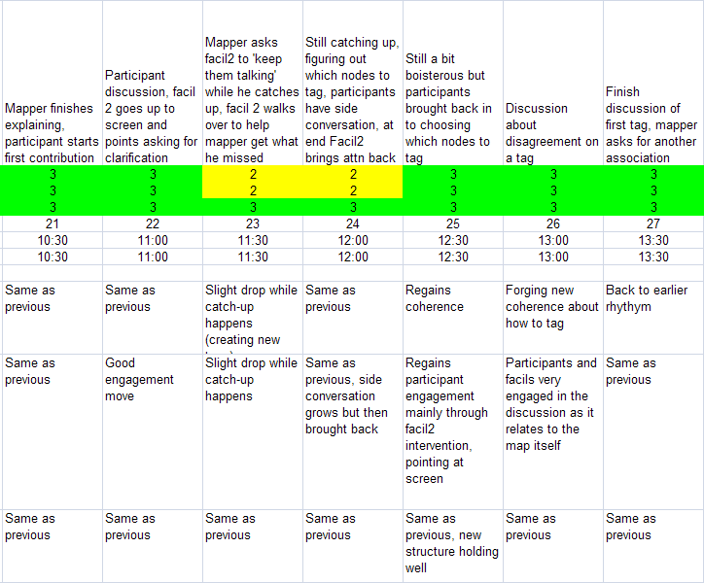
Full CEU Grid for sensemaking episode

Narrative description of the sensemaking episode

The sensemaking episode for Rutgers Group 2 spans the time from the first participant contribution to the second activity at 10:24 in timeslot 21 through the mapper’s solicitation of the next contribution at 13:20 in timeslot 27. It includes participant contributions, some confusion as the practitioners and participants sort through how exactly to conduct the activity, process offerings and decisions on the part of the practitioners, a decision to step out of the dialog at one point to bring the map up to date, recap/validations by the practitioners, and negotiation between participants and practitioners on how to proceed.

At the start of the episode, both S. and M. had provided introductions to the intended process of the second activity. At 10:24, participant Mn. jumped in with the first contribution:

Mn :Well I can pick one as being, um, this kind of came out …
Mapper: Which one are you referring to? [V10:29]
Mn: Um, well some of them I could connect to, um, like culture, art, because there’s a mention of a movie, a book, um, another movie….

Right off, it was not clear to the mapper which node to associate the contribution with, or what the wording of the tags should be, since the participant was not specific in her direction. The other facilitator, L., immediately stepped in to try to clarify. She walked up to the screen and pointed, using the shadow of her arm, to the nodes she thinks matches what Mn. was referring to.

L: OK, so, I’ll use my shadow here [pointing at the screen]. So this [overspeaking] Is that right? And then there’s an art, art museums, the Moma, and there’s a movie, … [V10:54]

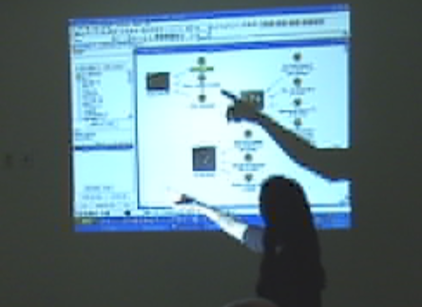
Figure 1: 10:51

The participants then begin to chime in on the way the tagging should happen:

Participant: … all of those are cultural.
L: …so you’re saying there’s a connection between these three? [V11:00]
D: Well and Tom Hanks and Ayn Rand also…
L: Right. OK so that’s Tom Hanks and then… Ayn Rand …

At this moment (11:05), the mapper, M., started to get behind and requests L. to continue the conversation while he catches up:

Mapper: [to L.] You keep ‘em talking, I gotta catch up to ya…

L. continues the dialog with the participants for a few moments until it appears that they have settled on a tag name of “arts and literature”, then walks back over to M. at about 11:17 to help him identify which nodes to tag. They choose to go “offline” from the participants for this, working together over the laptop, although they do engage in some bantering with the participants (who have continued animatedly discussing the issue until they start veering off onto other topics while M. and L. work closely on the laptop).

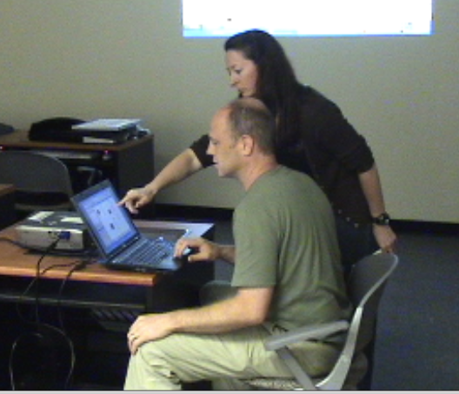
Figure 2: 11:22

At 11:58 L. appears to feel that they have brought the map back into its intended form, so L. begins trying to pull everyone back:

L: [going back to front of room] OK so lemme just, lemme just recap … so you said these these three [pointing at map] … was that right?

The participants continue their ‘side’ conversation during this, apparently not paying attention, so L. speaks a little more forcefully (12:06):

L: Mi… [the name of the participant who’s speaking/laughing, mostly with D.]
D: Sorry. [laughter and joking continue until 12:12]

When the laughter dies down, L. successfully engages the participants in validating that they have tagged the appropriate nodes and gathering additional clarifying input on which to include and which not, which M. captures on the fly:

L: OK, these three? And then Tom Hanks and Ayn Rand we said arts and literature, is there any…?
Participants: No, no… it’s those three, Tom Hanks and Superman… All five… five? [L.: Superman? ….] Oh, four…
L: …Superman is down here… [V12:22]

As this proceeds, L. continues to point at the nodes being mentioned on the screen, to make sure that they are capturing and tagging correctly.

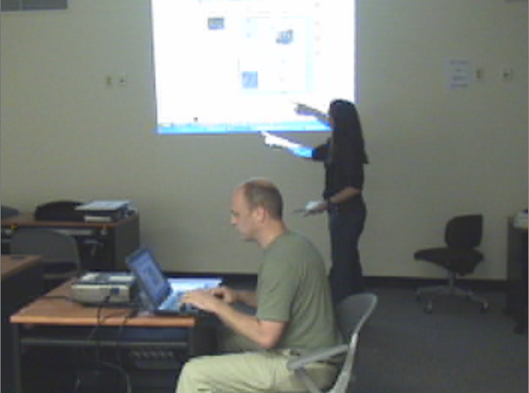
Figure 3: 12:22

Participant: Yeah.
Mapper: So this one’s not?
Participant: This one’s not. That one’s a philosophical…
Participant: That is correct. [V12:26]
L: Oh so it’s not literature it’s philosophy….

The next challenge to the smooth proceeding is at 12:28, when a participant disagrees with the point about separating “literature” from “philosophy” in the tagging scheme:

P: I disagree.
L: OK. She disagrees. [V12:30]
P: I think it’s …
M: [garbled]
P: I think it’s literature and philosophy.
Does the owner of the memory get to decide?
[garbled] on there…

L. validates P.’s right to disagree, but then M. the mapper indicates that the group has come to some consensus on the tags, that the “owner of the memory” doesn’t have refusal rights. However, he offers that the tag itself can be changed if the group agrees:

Mapper: No, it’s gotta be a group thing. But we can, we can change, we can change the tag, but the tag is arts and literature. But you want it to be arts, literature and philosophy? [V12:48]

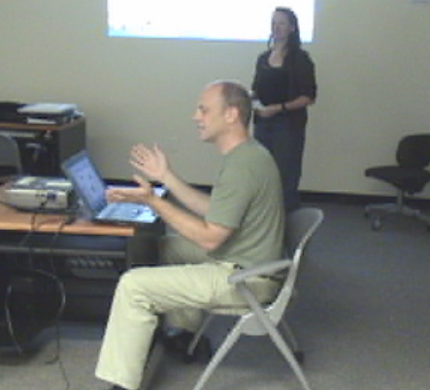
Figure 4: 12:42

The participants continue to debate this:

Participants: … so we need to have a literature… … that’s what I said… … arts literature and philosophy…
Mn: Philosophy should be a different tag. [V12:53]

At 12: 56 M. makes a further process offering in response to Mn’s contribution that argued that “philosophy” should be a different tag:

Mapper: Well, something can have more than one tag. I think. I mean, so. [Participant: Yeah]

He then proposes a specific matching of tag and node, including applying two tags to a node:

Mapper: So what are we doing [Participant: … on video over here…] So Ayn Rand , is this uh arts and literature? [V13:06]

This move appears to resonate with the participants, who then offer concrete responses:

Y: If it doesn’t have philosophy in it I would not put it there, no.
Mapper: OK.
P: Well double-tag it, that’s good.

L. adds to the specification by walking over to join M. at the laptop again and pointing out exactly which nodes should get what tags:

L: [pointing at M.’s screen, to M.] .. the one underneath of it, the Superman, they said yes, that gets the arts and literature tag.

The episode ends when M. asks for the next contribution and the discussion moves on:

Mapper: OK. So what’s another, what’s another, uh, association that you see. [V13:23]

Framing the moves and choices

c.

Element | Descriptive and normative questions
(A.1) Imposing their own coherence and values on a situation | - What coherence is the practitioner imposing on the situation?  The practitioners had developed a detailed plan for their session, and ran the session according to that plan. They also had some implicit assumptions about how the activities should take place (e.g. that the tags should be “a group thing” not up to the owner of a memory).  - What values is the practitioner imposing on the situation?  There was certainly a value of following a clear process and providing a clear structure for the participants to work within, then within those allowing the participants to provide whatever input in whatever style they chose. They kept the discussion clear and organized for the most part except when they needed to work on the map, so they emphasized coherence and clarity over strict control of the participants/discussion. At one point they encouraged the participants not to criticize each other’s contributions, just to generate them.  - In what ways are these congruent (or not) with those of the participants?  There did not appear to be any incongruence in values (in part due to the collegiality and familiarity among the participants). However, at the one point in the sensemaking episode, there was a potential incongruence with the issue about the owner of the memory getting veto power over the tagging.
(A.2) Constructing narratives to account for how the situation arrived at the current pass / breaches in canonicity | - What is the narrative the practitioner is using to construct the situation?  A combination of the assigned exercise, and the plan they had developed in their planning session. This also included a further trajectory to a comparative exercise that even could have research implications. They had envisioned their exercise as something reaching into their research area.  - What is its degree of internal consistency?  It appeared to be quite consistent. No breaches emerged during its unfolding in the large group session.  - How evocative and inclusive is it?  Except for the emergent issue of “ownership” over tags associated with the memory nodes, the activities and performance of the exercises appeared to be very inclusive. All the participants were engaged and each given equal and non-prejudicial chances to contribute.  - How useful is it?  The practitioners did not give much context in their introductions of the activities beyond what was necessary to guide participation. The ‘usefulness’ of the exercise might have become more apparent had they moved on to the third activity, which they ran out of time for.
(A.3) Eliminating prejudices and preconceptions | - What prejudices may be active?  - What preconceptions may be active?  - What personal desires or goals may be active?  None were discernible within the boundaries of the session, other than possibly a “prejudice” towards a highly structured activity as opposed to an improvisational one.
(A.4) Personal authenticity in the practice setting | - In what ways is the practitioner acting in an authentic manner (vs. received, affected, etc.)?  All the practitioners appeared to be acting authentically and were present in the session. There was a bit of received-ness on the part of the first introducer who appeared, slightly, to be acting a part rather than being fully authentic in the moment, but this was slight.
(A.5) Mediated objects and other interventions should preserve openness and dialogicity | - How do the representations the practitioner constructs or modifies foster openness and dialogicity?  The nature of the planned activities and the representations, with their highly structured process and pre-determined limits and outcomes, did not lend itself to dialogicity, though it could have (certainly the participants jumped enthusiastically into discussion whenever they weren’t actively brought back to the planned tasks by the facilitator). However, as noted above, within the structure of the activities, participants were free to provide (or not provide) any kind of input they wanted, which constituted a high degree of openness.  - How do they inhibit them?  Since there were pre-determined kinds of contributions and outcomes, the representation could be said to foster some inhibition, but given the bounded nature of the session (15 minutes) this was not manifest in any meaningful way.
(A.6) Artifacts should be clear, expressive, and helpful | - How clear are the artifacts produced/modified by the practitioner?  The representational artifact was very clear, though additional annotation could have been provided that would have made it more clear to a new participant what the relationships between the elements were (e.g., nothing said that the nodes linked to the images were “memories” per se). However, given some background knowledge, the artifacts were well organized, succinctly worded, and clear.  - How expressive are they?  Given the contextual knowledge that the linked nodes were “memories’ and the tags were thematic groupings of the memories, the representation was quite expressive.  - How helpful are they within the context of practice?  Once the participants understood what they were to do in each of the activities, the representational artifact served well to guide and ‘remember’ the contributions and associations.
(A.7) Perseverance in the face of checks and resistance | - What checks to forward progress does the practitioner encounter?  The main checks were some initial confusion on the part of the participants as to what kinds of contributions they were expected to make, and more the several occurrences where the mapper got behind. Some minor impediment due to the boisterousness of the participants.  - What resistance from participants, materials, etc. occurs?  Some initial mild resistance from participants who were not born at the time of the moon landing, and later the discomfort of P. who felt that she should ‘own’ the themes assigned to the memory she had contributed.  - How does the practitioner respond in the face of these?  When the mapper got behind, the facilitators needed to caucus to catch up. They employed two strategies (arrived at on the fly): in the first, the facilitator ‘kept them talking’ while the mapper worked alone ‘offline’ on the map; in the second, the facilitator walked over and worked directly with the mapper to help him catch up (this occurred twice). When the participants grew boisterous, the facilitator intervened verbally (with humor) to bring them back on track.
(A.8) Clear and focused communication | - How clear is the practitioner's verbal communication?  All three practitioners were very clear in their communication. There was some initial flippancy on the part of the mapper but this vanished quickly as they engaged with the body of the activities.  - In what ways does the practitioner maintain focus on the aspects of importance in the situation?  By closely following their well-thought-out plan, and by making very concrete moves to bring the attention of the participants to the nodes and associations of interest, pointing clearly at the screen so that all participants could see, and by repeated and careful verbal as well as pictoral/spatial validation.
(B.1) The importance of participants' impulses and desires; attention to what may be bothering or affecting participants | - What observable or discoverable participant impulses, desires, or other factors are operating in the situation?  There were two clearly observable impulses on the part of the participants: enthusiastic desire to participate and engage once the directions were clear to them, and a good degree of boisterousness and willingness to joke around with each other, that sometimes temporarily took over the proceedings until reigned in by the facilitator. It also appeared as though some of the memories evoked became personal expressions for some of the participants, some provoked what might have become arguments, or that they felt some need to defend the ‘turf’ of their contributions (e.g. the Ayn Rand discussion).  - How does the practitioner address these?  Within the 15 minute boundaries of the session, there was not much time to address the small issues that arose. The facilitators acted quickly to make decisions about process and cut off argument.
(B.2) Unfinalizability; preserve room for surprise, imagination, and creativity to emerge | - In what ways do the practitioner's actions reflect an attitude of unfinalizability toward the participants and their interests, concerns, and agency?  Within the context of this limited-time session, this mostly manifested in the openness to the kinds of contributions participants could make within the tight structures of the intended activities. The practitioners were careful not to prefer one kind of contribution over another, or to say one was more right than another. Participants could be as imaginative as they wanted with their contributions, and several were quite evocative.  - In what ways does the practitioner preserve or close off room for surprise, imagination, and creativity to emerge?  Although it might be said that the tight structure closed off some room for surprise, within its constraints, there was a good deal of surprise in the kinds of contributions that were made and accepted. The openness of the representation and instructions, coupled with the verbal acceptance and affirmation of the diverse contributions (and regulatory actions against debate or criticism), helped to keep the ‘doors’ open.
(B.3) Dialogic orientation | - How do the practitioner's actions and communication open up or close off dialogue in the situation?  - In what ways does the practitioner display openness and sensitivity to the different participant voices (vs. summarizing them into abstractions or types)?  Covered in A5, B2, and elsewhere above.
(C.1) Heightened degree of connection between people, setting, purpose, and medium | - How do the practitioner's actions help create this kind of connection and integration?  Other than fostering an atmosphere of humorous and creative exchange (in terms of contributions), and allowing more personal memories and statements to emerge and be counted, there was not much opportunity for this within the short confines of the session. However, there was a high degree of connection between the participants, exercise, and representation; the discussion and representation were strongly coupled and the participants maintained a high degree of engagement with the representation throughout (except when the mapper got behind and side conversations were left to blossom for a few moment).  - In what ways are the distinctions or boundaries between people, setting, objects, etc. made stronger or lesser?  Not really applicable for this session.
(C.2) High level and quality of communication | - How does the practitioner elevate (or diminish) the level and quality of communication in the practice setting?  This happens mostly through the combination of openness and structure (as well as willingness to cut off side discussions) discussed above.
(C.3) Importance of the past as the background and context to the practice setting | - In what ways does the practitioner reference or bring in elements of past work, ideas, or events?  - Are such "background" elements combined with "foreground" (current) concerns, ideas, or representations?  The main body of the session had to do with linking personal memories, which of course have strong relationship with past ideas and events, to the present concerns of creating associations and themes within the exercise. However within the boundaries short session, there was no other explicit connection to past work or ideas.
(C.4) The relationships of parts to parts and to the whole | - How does the practitioner focus on both individual details and the relationships of those details to the 'big picture' and each other?  The practitioners created a highly structured set of representational ‘seeds’ and activities in which the representation of the parts (images, memories, themes) was pre-determined and kept well managed throughout the session.  - How are the moves from parts to whole accomplished?  The practitioners relied on the somewhat tricky (given their level of experience with the software) manipulation of the separately gathered memory and image nodes, into one ‘page’ of the map for the second activity. Once they managed that, they used a lot of pointing and verbal statements to help the participants do the thematic grouping that made up the second activity (which in and of itself went a long way to relate the parts to the whole).

