Dwight (mapper), Megan, Michelle, Pam, Yanna
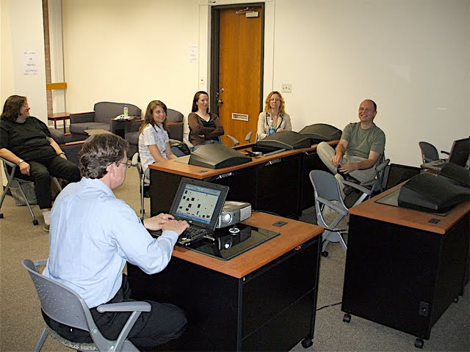
[19:41]
D: OK so as we scanned the initial bank of images, we what we saw in there was outcomes and uh values of the space program. So we’ve taken the liberty to assist you, by grouping those images, and what we would like to do is for you for us have a discussion, and go back and label those idea nodes as to what they might represent. Based on our previous grouping. [20:09]
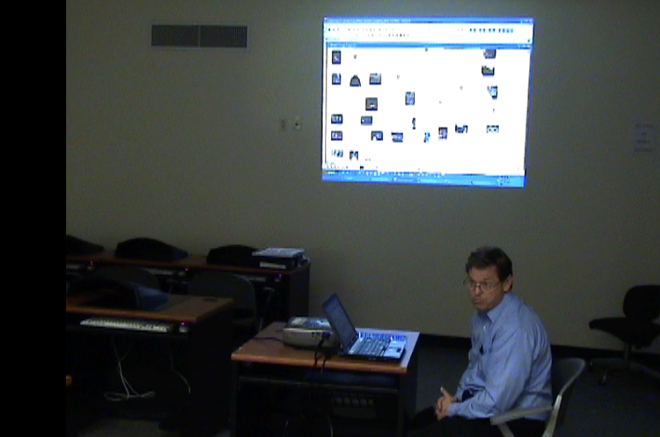
[20:11]
Mk: You don’t have any pre-determined meaning for the node, you you want us to come up with something. [20:14]
Mi: Well… [D: We actually do…]we do, but we want to see what you come up with, in relation to what we came up with? and then there are images we didn’t group, and, at the time we put them in, [Y: initially pulled out one…] [Mk: OK] especially ones …
… to see where you get those…
D: So we’ll just …
Mk: Ok…
[20:25]
So we’ll …
Y: … like to see where you put those…
D: So we’ll look at one node at a time [Mi: Yeah, one node at a time… ] just to make it more convenient.
Y: And if you’re…
Mi: And again it’s….
D: We’re all about convenience.
[20:33]
Mn: The overall question is in what ways has the space program been of value.
[20:39]
Mk: OK.
D: And so these three images are associated with the first node.
[20:43]
D: OK? … so these three images.
[20:49]
?: Let me dwell on each one for a second.
Mk: Can you , We just go through each one slowly.
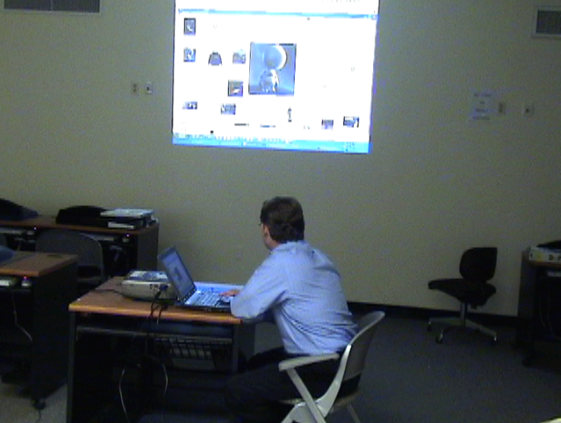D: OK. Can you see that one…
[group looks at the images as D rolls over each]
[murmured discussion]
[21:15]
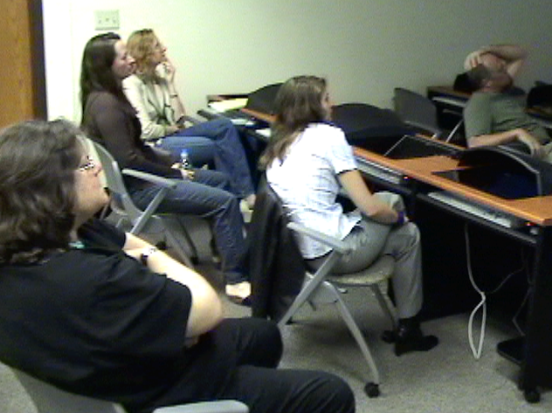
Mk: I don’t know, it’s like changing beliefs, about man’s relationship, man and woman’s relationship to the moon?
L: Huh?
[21:20]
D: [typing what Mk had said into the node contents window] Changing beliefs… about… Mark.
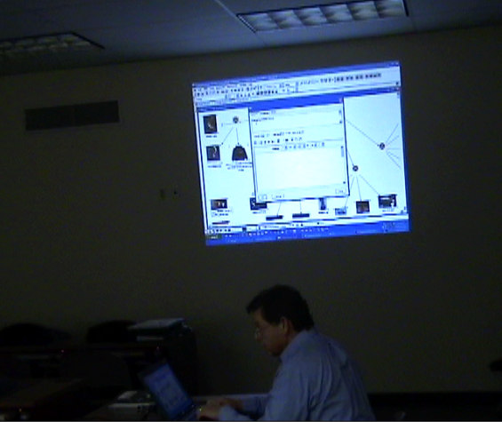

Mk: Well actually I dunno, it’s like two are cultural products, like Hitchhiker’s Guide…
[21:32]
L: …what am I answering, again?
Mk: We gotta come up with a label for the, for the lightbulb.. for the lightbulb…
L: The group?
[21:40]
Mi: That has to do with how the space program adds value.
Y: What kind of value do these images, do we think that these images…
[…]
L: And what’s the what’s the last image, again?
[21:51]
D: This one?
L: No, the one on… oh, the…
[several talking at once]

[END OF TIMESLOT 4]

Mk: Pink Floyd, Hitchhiker’s Guide to the Galaxy, [L: Ah.] and the woman looking at the moon through the window.
[22:00]
Y: It’s Ayn Rand…. [laughter] Atlas Shrugged…
D: The moon over Moscow, that’s the moon over Moscow…
Uh-huh…
[22:12]
L: All of these have to do with like what people do at home…
Y: … always very cloudy, you can’t see the sun or the moon… [laughs]
[22:15]
L: Things people do at home? [laughter]
[several talking at once]
…Things people do at home. [continued laughter]

[END OF TIMESLOT 5]

L: That’s what it means to me [laughter]
[22:27]
[22:28]
Mi: How does that have to do with the space program adding value, though. That’s the catch.
[22:34]
L: Oh, ok. Yeah.
Mi: This isn’t just how could these three things be grouped.
L: Uh…. How the space program adds value.
[22:45]
Mk: Well it could be….
?: … benefits…
Mk: Well, we get new kinds of books and music. I dunno. [laughs] What do you think Lisa.
[22:54]
Mk: I feel like I’m trying to guess what’s on their mind.
D: No, …

[END OF TIMESLOT 6]

[Others]: No, this is what…
L: You guys just come up with an answer to that question.
[23:02]
Mi: It’s actually more interesting if you come up with something entirely different.
L: Um…
P: But I can see why they would guess, it kind of
[23:10]
L: … it gives us something to think about actually…
D: Ok so what we said is new, new kinds of books …
Mk: New cultural products.
D: … new cultural products and books..
[23:16]
Mk: … spurred the cultural imagination. Before you could only sit and look at the moon in wonder. Now, you can write books about it.
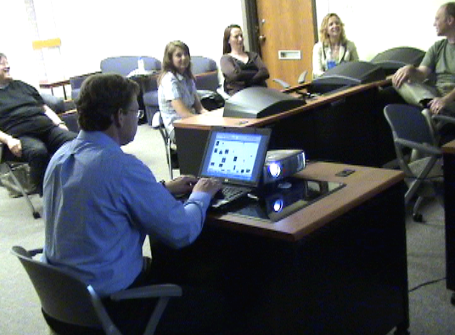

L: And watch movies about it.

[END OF TIMESLOT 7]

[23:29]
Y: … the conceptualization of gender differences and…?
Mk: … and the conceptualization of gender differences.
[laughter]
Mk: That really covers everything.
?: …don’t put that..
[23:37]
[chatter]
D: Are we ok, re we OK to move on to the next node?
[23:43]
Mi: … in the … interest of time…
Mk: We don’t have the, I love you to the moon and back, where’s that one.
D: Yeah, well, we were limited…
[laughter]
D: OK let’s look at uh, this one now.
[23:53]

[END OF TIMESLOT 8]

D: Alright? So I’ll go through the images.
Mk: Drumset… oh. [looking at screen]
[laughter]
Y: … Familiar with our framework now…
Mk: … the cymbal…
D: That there’s the drumset and the cymbal.
[24:08]
That’s a satellite..
Mk: oh that’s a…
… to look at…
Mk: That’s the Hubble.
[24:17]
D: Another… series of satellites… And this.
[24:25]
Mi: Which you should explain what you think that is because …
D: How, how do we articulate that.
Mk: That looks like…
Y: We got this from like a sample of matter…
L: … sample…
Mi: The idea of, trying to associate with the idea of, the fact that we can study medicine.
Mk: Cheese.
Mi: …In space.
Mk: what sorry! [laughs]
D: Yeah well that’s a, that’s a cultural artifact.
… that covers everything. [laughter]
… the example…
… you’re close…
D: The idea here was medicine, and development, you know that…
[24:52]
D: We thought of this…
L: So what is the question,
Mk: … we got a a bunch of machinery…
L: …what is the question for this group.. is the same question…
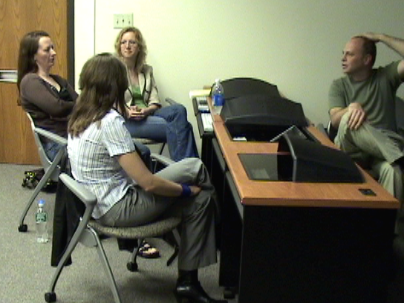

Mi: Same question.
D: Same question.
Mk: Value of…
[24:58]
What is the value of the space program. [several saying this]
D: We think that value is reflected in this collection of pictures.
L: Right.
D: There’s a good one…
L: Um…
Mk: We have ways of looking, we have mechanical ways of dealing with the rest of the universe?
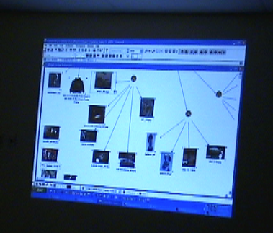[25:11]
Y: Do you think’s that’s a value… [laughs]
L: It’s a…
Mk: .. it’s a valuable thing.
Mk: Are you talking about, oh that’s good. … are you talking [Yes yes yes yes yes] about the value of freedom? Or are you talking about
Mi: No no no we’re talking about, a benefit
D: A contribution. [a contribution]
L: It’s a place that people that people, I dunno … build machines to study…

D: Yeah. [leans fwd to type that in]
L: …gives people something to do…

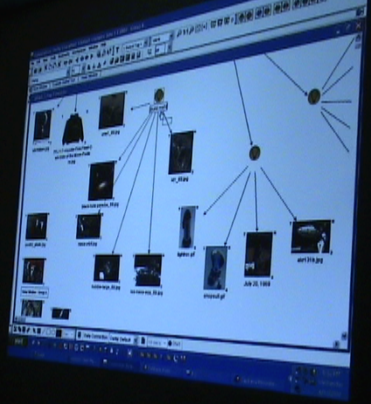
[laughter]
[25:37]
L: I don’t know, like I’m real vague.
Mi: Gives people something to do.
Mk: Build machines …
L: They’re building all these machines for space …
[laughter]
Mk: For further exploration of space.
D: OK. OK.
Y: … we’re sitting here …
L: … y’,know, the industrial age, gives people… it’s an argument it gives people something to do. That’d be the right argument.
Y: That’s that’s the bottom line.
[25:59]
D: OK we’ll, we’ll uh,
Mi: OK!
Mi: Not here to censor, here for reactions…
Mk: We’re here for the semiotic abyss.
?: No! [laughter]
D: In what ways does the space program, … [trying to bring them back]
[laughter, chatter]
… next group…
D: …in what ways has the space program been of value, and then we’re gonna get a group 3 down here, which I just did a drive-by… [scrolled too far]
Mk: Let’s give him a… answers….
[26:23]
D: OK. This is uh like a toy [Mk: Toys.] rocket? This is… Snoopy.
[26:36]
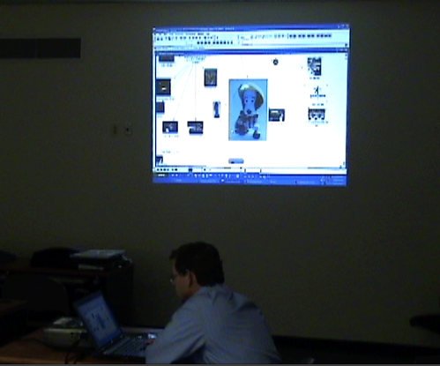?: and bigyear [?] woman. [laughter]
Mk: What’s the, show the July 20th one again. [D hovers over that image node again]
[26:45]
D: It’s a poster, …
Mk: It’s like, y’know, the three belong together … [laughter]
L: Yeah I was gonna say the three things are sort of like, cultural icon heroes… [yeah, yeah ok well…] Dolls and….
Mk: Snoopy…
D: What were … This is for you to solve.
Mk: Toys!
Mn: Heroes, that’s a good word. Heroes, that’s a good word.
Mk: Icons!
Icons.
L: There ya go. Icons.
[27:10]
Mk: Toys.
D: Cultural icons.
Mk: As.. play… products.
[27:17]
Mk: Play toys. Playthings.
L: Sounds very cultural…
Mk: Because if it’s not like they’re statues as icons, that were built to put in a park somewhere. It’s like something given to a kid to play with.
L: Usable…
Mk: Reusable..
Y: Reusable! [laughs]
D: Our fourth… Our fourth and final grouping… in what ways…
[laugher, chatter … the pressure level there…]
D: in what ways is the space program been of value?
[27:44]
D: That’s a, I think Mercury capsule.
Mk: Yeah I remember that country. [looking at ussr pic? laughter]
D: Don’t take that, don’t take that personally.
Mi: That’s Hindi.
Mk: Ah.
[28:04]
L: … also… star trek…
Mk: Are those cosmonauts?
D: Uh, they’re actually space travelers. Travel space tourists. So you can see the title.
[28:15]
?: Or… people with lots of money.
… last night…
Mk: Guy from .. came to my daughter’s school on his way on to…
D: That cost quite a bit.
?: A couple million.
Mn: Well if you have to ask you can’t afford it.
[28:35]
[laughter]
D: Meghan … we all knew that that already…
Mk: Ah let’s see um, I guess space travel.
L: Well and, I guess what I’m seeing in the pictures is a way um, it creates a sort of a community where different countries participate? In, I dunno …
Mk: …space travel.
L: Yeah, there ya go.
Mk: That’s actually almost a sentence.
L: Together it is.
D: Countries participate in space travel? Is that the… [validating]
?: Mm-hm.
Y: I’m used to uh…
D: That’s great. You guys are building sentences here.
[29:11]

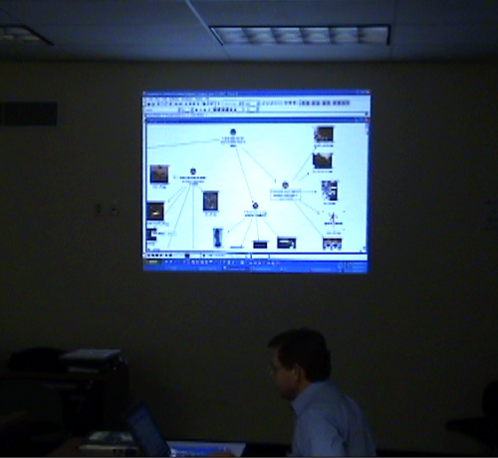

D: OK! So.
?: And then we had the ones there on the bottom.

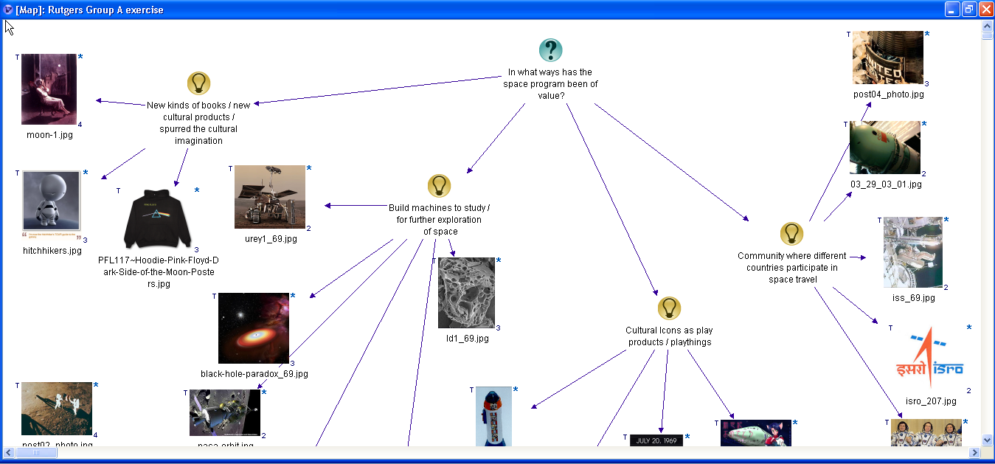

[About, uh, four minutes.]
Mi: Four minutes, OK.
D: I think the four minutes is enough to share the previous titles?
?: No no no let’s…
Mk: What is the next thing?
?: Well we’re gonna see…
D: The next thing is that we have things that we were remaining, remained ungrouped.
[29:30]
Mk: Oh ok.
D: And we were gonna allow you time to group them.
Mk: Ohh.
?: Right.
Mk: Well the, Challenger explosion, the, those rockets flying, and all the ones to the right, I’d put under space travel.

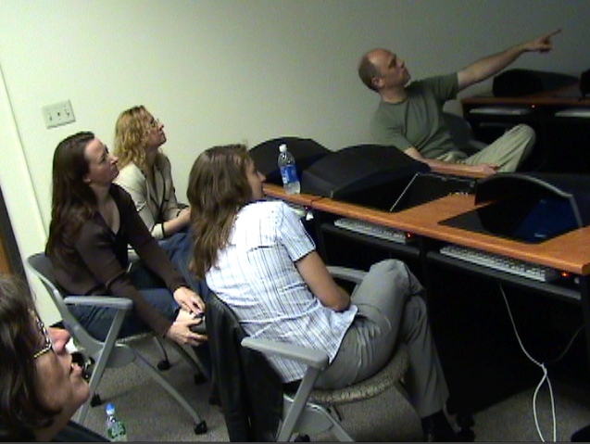

L: Well there’s …
[29:40]
D: Do we want to do that, or…
L: Yeah, but aren’t they all,…
Mk: I’d almost put all of them …
?: Look at the…
?: ..all the same thing….
Mi: Which space travel thing, so…
L: Y’mean the international thing, or the community, is that what you’re saying?
Mk: Yeah, somehow .Probably emphasizing more space travel .
[30:07]
D: OK. Are we allright to, rather than move all those are we ok to go to our titles?
L: You’re gonna reveal to us, [yeah] the uh..
D: It’s too bad we can’t have a in here somewhere.
?: behind…
Mi: We did have the export, can we import that back in?
D: Yeah we almost need it up here ok. For this first one? Who has the list.
Y: I do.
D: OK. You identified these, our pre-selected has new kinds of books, new cultural products, spurred the cultural imagination. [30:40] Yanna what was our group entitled.
Y: We had cultural impact. Artistic expression.
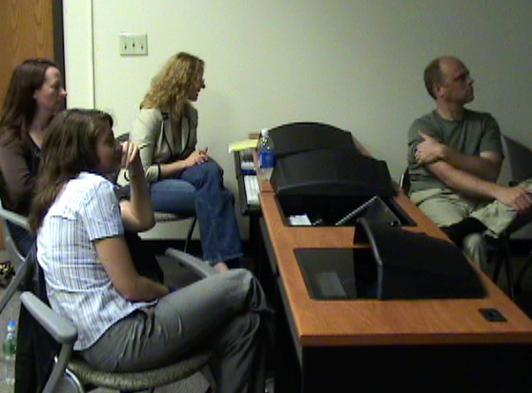

So It’s very close.
Very close.
Really close.
D: Very close. [30:47]
Yeah.
D: The second one? You have build machines to study, and for further exploration of space?
Y: This was, um, ‘advance scientific and technological development.’ [31:02]
MK: Close, [L: yeah], close…
P: A little different because this is space related, we were trying to get , [Mk: Overall.] extrapolation,
D: Scientific. Materials, medicine,
P: medical…
Tang.
Tang.
Yeah.
D: This one?
Y:: This was actually an interesting one. An inspiration for the next generation.
Mi: Yeah these are things to inspire the younger generation. Sort of keep the…
Y: There’s our artifact, to demonstrate…
D: Well it’s interesting though, because you go about as far as you play, you could argue that…
Culture means
yeah
Next generation,…
Mk: Ours is less normative. [31:44] Prescriptive.
That’s right.
P: You see icons, icons that have a purpose. [laughter]
[31:51]
D: And then finally, um you had community where different countries participate in space travel?
Y: and we had more of what Lisa was talking about um cause several countries coming together in international collaboration.
Mi: Yeah it wasn’t really space travel part as much as
D: Just cultural collaboration.
Mi: Yeah. .. [Mk: Yeah, …] really bringing the world together.
Mk: …. Real imperialist…
L: No but I like the pragmatic….. like what are they doing, they’re traveling in space.
Mi: So…
D: So now we have… we have both of the …
Mk: … I can’t see…
L: So, so what do ya think. About this exercise. How’d we do.
Mi: It wasn’t a test.
D: You got a, you got a check plus.
[laughter]
Mk: A for participation..
I’m kidding I’m just kidding.
Mi: No I was surprised at how close they were actually. Especially on such a short time and to go through this. You have to … pick out…

Mk: But you did some of the work for us, by grouping ..
Mi: Right but they’re not so obvious that they’re and they’re all space related to it’s not like one of these is space and one is the ocean
D: Pretty interesting they’re that close.
Mk: Yeah I think the space framing and the grouping
L: It already got us….
Mk: …Got us in the same space…
L: Right.
D: Alright. So that’s the end of our exercise. Thank you.
[33:26]
Mk: Probably also sort of a common sorta… things people say about space. too .. there were a lot of things helping to get..
D: …except for Yana we all share kind of a cultural perspective.
L: She’s got her own perspective…
D: It was very different in there I’ll tell ya.

