# Sensemaking Moment – Narrative Analysis: Ames Group 4

This session was marked by effective collaboration between the mapper and facilitator, with good engagement throughout. The only small breakdowns were in the early going when the mapper had trouble with the mouse, and some minor bleeps when it was hard to find the right place on the rather messy map. However, the structure and project held up well and coherence was well maintained throughout, helped especially by the speed of mapping and the ‘governing’ that the facilitator did, holding not-yet-mapped contributions in her memory than repeating them for the benefit of the mapper, continually directing participants back to the map, etc.

There is no showstopper obstacle or anomaly per se in the session, nothing that throws it off the track for more than a few seconds (except the mouse issue but that is somewhat extrinsic to the session itself). Rather there are a few short hiatuses in the flow, that are overcome quickly, through a combination of:

* Good teamwork between mapper and facilitator (both of whom were experienced and fluid in their roles)
* Good direction, feedback, and ‘readback’ by the facilitator (prompting of participants, remembering and supplying previous contributions, etc.)
* Good questioning of participant contributions and validation after mapping (in some cases)
* Speedy typing and mapping by the mapper
* A well-chosen, coherent format (though it did get crowded and messy) that held up in the course of the exercise
* A straightforward dialog mapping approach; controlling the flow well enough to make it work
* Frequent reiterations of scope and expected contribution type from the facilitator

So for this analysis, will choose a short episode that shows how things could’ve gone off the rails but didn’t due to factors like the above.

## Overall CEU scoring table, heat map, and CEU graph





Overall scoring and heat map for Ames Group 4

Looking at the whole-session scores, the Overall score is the highest-scoring group of the four Ames sessions (2.8), and on par with both Rutgers groups.

The CEU graph shows the short-lived drop in Coherence (blue) and Engagement (pink) as the mapper struggles to get back on track after some confusion with an unfamiliar trackpad.

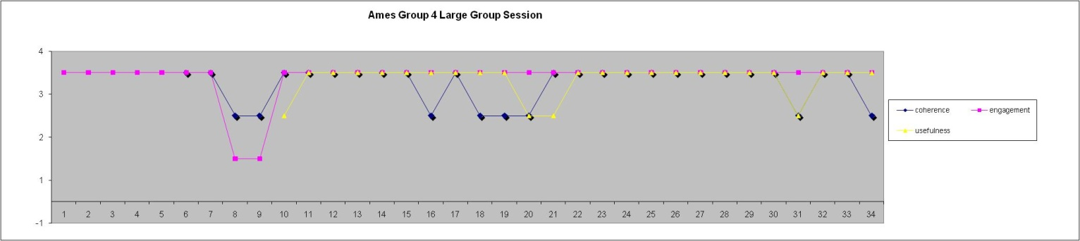

CEU Graph for sensemaking episode

The full CEU grid provides further detail on what occurred and the CEU ratings in each timeslot:

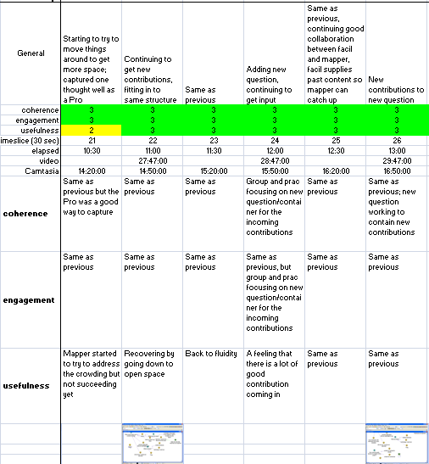

Full CEU Grid for sensemaking episode

## Narrative description of the sensemaking episode

The episode described here is 1m56s long, from C14:32 – 16:28 (timeslots 21 – 26).

The sensemaking episode chosen starts at C14:32 with a new contribution from participant E. Another contribution (“tell me how I could be an astronaut”) had just been mapped and validated, and he threw in the next one building on the previous thought.

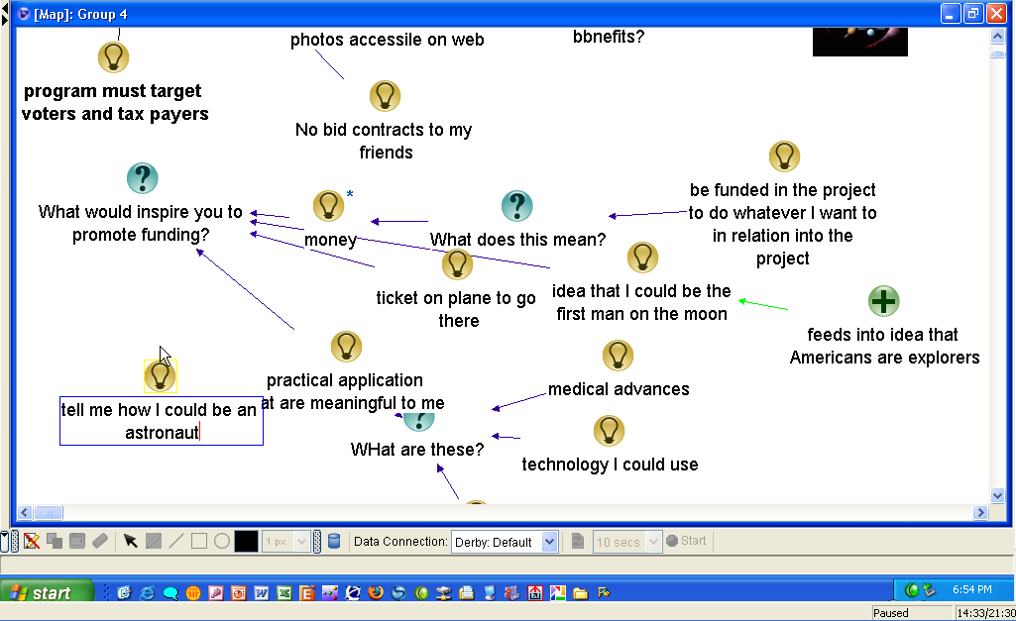

E: Y’know and part of that actually is, is more sort of close interaction like with the people… like I love meeting astronauts, y’know .. and I still like meeting astronauts hearing about, hearing their stories and all that. [V27:42, C14:48]

.

The mapper does some cleanup to previous nodes during this speech, then positions a new node for the contribution at C14:46:

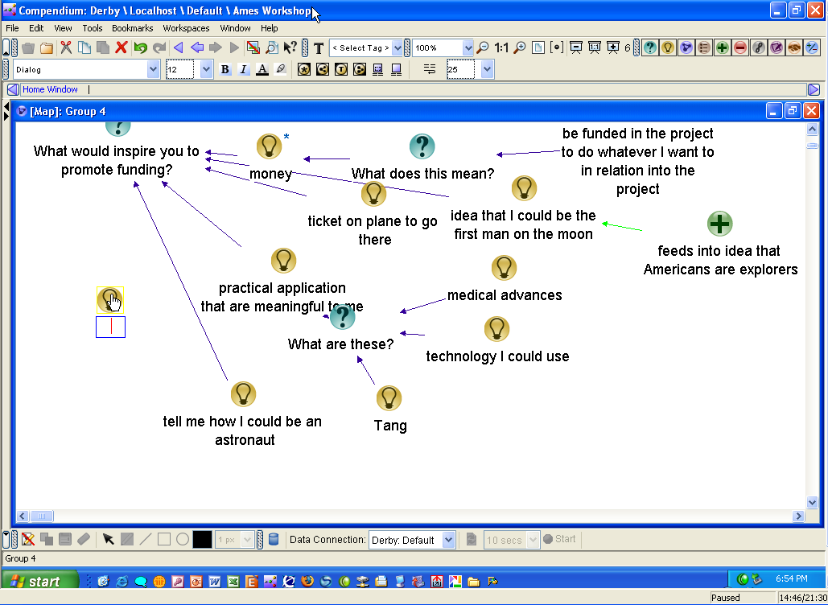

Figure : Map at 14:46

but might have missed some of the details, so the facilitator (D.) provides a helpful reiteration (in bold):

D: So **close interaction with astronauts** …

E: Or with the rocket scientists.

D: Or close interaction with those involved. **Astronauts and rocket scientists, yeah**. [V27:51]

The last bolded point was a validation as the mapper (L.) typed the phrase “and rocket scientists”, confirming that she had captured the point accurately.

An even better example comes in the next segment. The same participant, E., make a fairly long speech to think through and establish the next point he wanted to make:

[C15:08] E: I think also sort of one of the underlying things I don’t think it was exactly J’s point but I think it’s relevant here is, is um, people are more uh invested in something if they feel like they are co-creators? Like they’re part of it? So if there are ways to involve the public like in terms of decision-making, like if you had contests where the public could actually come up with an advertisement for an example. [V28:27, C15:31]

From 15:08 to 15:15, L. was doing clean up moves in various places around the map. At 15:19 she moved the cursor around as if searching for the right place on the map to capture the point, settling on a place at 15:24, which she then moves to two different places until 15:28. At 15:29 before E. stops speaking, she starts typing “contests” but then backspaces over it as D. starts rephrasing/summarizing, then deletes the node at 15:37 in response to D’s “if we put a question” at 15:33 or s, creating a Question at 15:39. D. then prompts L. to create specific Idea nodes in response, and also directs/simultaneously narrates at C15:51 as L. scrolls the map up so the question can be seen more easily on the map.

[C15:32] D: So if we put a question that said how could the public become co-creators? Of the program? [V28:33] And then let’s capture a couple of your, your ideas about that.

D. ‘s statements here provide a “plan” for L. to follow. As L. starts to create the Idea “contest for commercial”, D says the above statement about “So if we put a question that said how could the public become co-creators?”, which prompts L to abandon the node (first erasing the text then deleting the node itself) then creating the new Question “How could the public become co-creators of the project?” That takes from C15:39 through C15:50, while D. had already finished the above speech. Then, since the new Question’s label displayed below the bottom of the visible map:

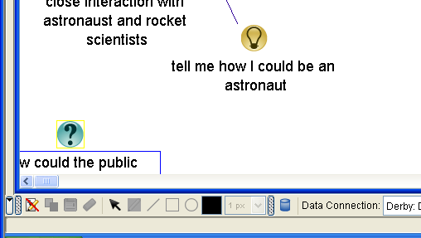

L. moves over to the right scollbar to scroll the map up, while D. simultaneously buys her time, explains what L.’s doing, and prompts her to create the next nodes:

D: Um… I think .. [C15:51] **just move that up a little so we can all see it** and then I think he said what was it? One was a contest for…[C15:59]

Other participants chime in in response to this prompts, supplying the content for L. to create new nodes for (L. herself provides one of these prompts):

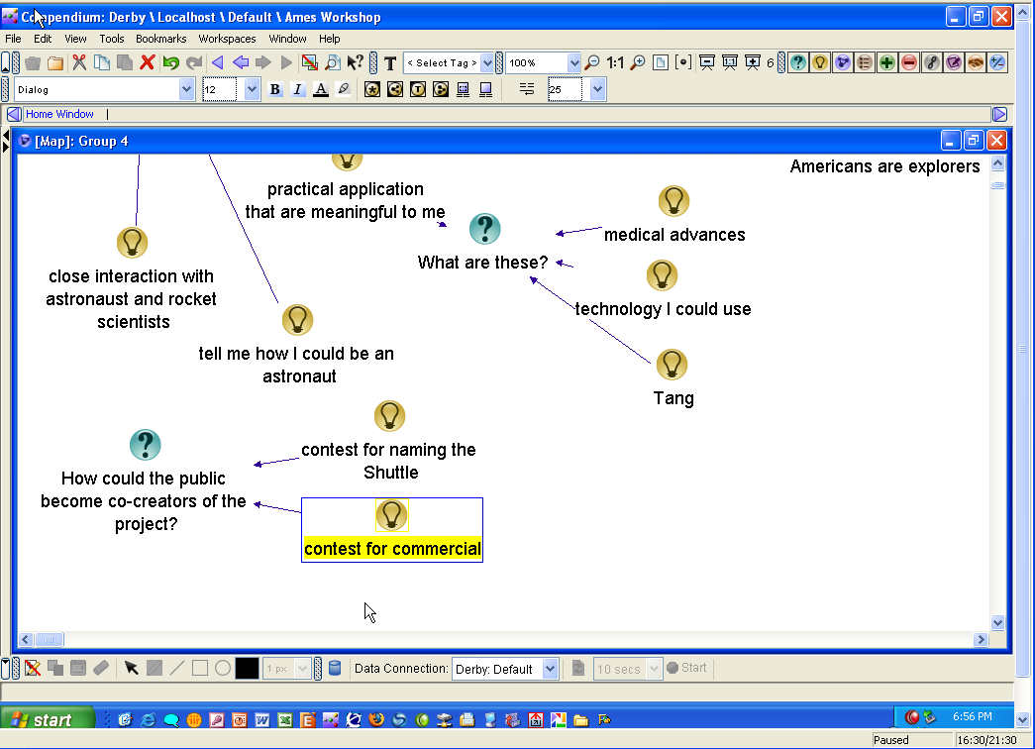

E: H. had a great one.

H: Name the shuttle, type of thing. [V28:57, C16:00]

D: For naming the shuttle, was, you had, you had an idea too didn’t you?

E: Yeah, it was just a contest for, I don’t even remember what it was now.

D: Allright, so this was a good example and there could be other ways…

L: Advertising campaign you said didn’t you?

H: Advertising…

E: Oh right right yeah right, ok, commercial contest. [V29:17]

H: Commercial contest, that’s becoming… y’know… in vogue.

D: Ok great. [C16:28]

The sequence ends with D’s “Ok great” acknowledgement that L. had captured the contributions accurately.

# Framing the moves and choices

.

| **Element** | **Descriptive and normative questions** |
| --- | --- |
| (A.1) Imposing their own coherence and values on a situation | * *What coherence is the practitioner imposing on the situation?*   The facilitator and mapper kept the concept and structure of the original planned exercise throughout the session, though were flexible in allowing participants to throw in contributions that might have seemed slightly off track. They kept a consistent issue-position approach throughout and kept both the conversation and map-capturing flowing.   * *What values is the practitioner imposing on the situation?*   A value of keeping the map up to date and inclusive.   * *In what ways are these congruent (or not) with those of the participants?*   No discernible lack of congruence. Participants were engaged throughout and appeared to be satisfied with the ways the contributions were being mapped. |
| (A.2) Constructing narratives to account for how the situation arrived at the current pass / breaches in canonicity | * *What is the narrative the practitioner is using to construct the situation?*   The facilitator laid out an intended narrative (defining ‘components’ of a proposed education program) in the start of the session and referred consistently to it throughout.   * *What is its degree of internal consistency?*   It seemed internally consistent. There were several moments when the practitioners had to think/discuss how something fit in, but were able to construct containers that included the contributions fairly seamlessly throughout.   * *How evocative and inclusive is it?* * *How useful is it?*   It worked to contain all of the contributions as noted above. |
| (A.3) Eliminating prejudices and preconceptions | * *What prejudices may be active?* * *What preconceptions may be active?*   None discernible in this session.   * *What personal desires or goals may be active?*   None discernible in this session. The practitioners appeared to act altruistically throughout. |
| (A.4) Personal authenticity in the practice setting | * *In what ways is the practitioner acting in an authentic manner (vs. received, affected, etc.)?* Aside from adopting the pretend persona of someone gathering info for an educational program, and some slightly affected facilitator-ish behavior, the practitioners both seemed to be acting authentically and in the moment. |
| (A.5) Mediated objects and other interventions should preserve openness and dialogicity | * *How do the representations the practitioner constructs or modifies foster openness and dialogicity?*   By following a consistent question/answer format and by taking pains to be sure that all contributions were mapped (sometimes asking for clarification until it was clear how they could be mapped), the practitioners and the representation seemed open and amenable to dialogicity. However there was not very much sustained dialoge on any one issue (which to be fair was not the intent of the session).   * *How do they inhibit them?* No discernible inhibition. Given the way the contributions were represented, dialogue could have easily occurred if time had permitted. |
| (A.6) Artifacts should be clear, expressive, and helpful | * *How clear are the artifacts produced/modified by the practitioner?* The representation was kept clear and coherent throughout, with some temporary dips due to clutter. * *How expressive are they?*   There was nothing especially expressive about the artifacts themselves beyond their capturing of participant articulations. The opening (pre-supplied) artifacts were not referred to very much beyond the first few minutes, but that did not inhibit the session.   * *How helpful are they within the context of practice?* They served to help keep the contributions flowing and captured. |
| (A.7) Perseverance in the face of checks and resistance | * *What checks to forward progress does the practitioner encounter?*   There were several checks. The first came when the mapper was unfamiliar with the trackpad and had trouble adjusting to it. This lasted from about C7:14 to C8:16. There were several other times when it wasn’t immediately apparent how a participant contribution fit in and clarification was needed, and a few times when the mapper got behind in the process of cleaning up or finding space.   * *What resistance from participants, materials, etc. occurs?*   Aside from the several times where the mapper ran out of space and had to move things around then catch up, there wasn’t much resistance in this session.   * *How does the practitioner respond in the face of these?*   When the trackpad problem happened, the mapper essentially stopped the proceedings until she got used to it, giving verbal narration as she wrestled with it (“No.. ok… never mind, I’m just gonna get used to it, you guys, it’ll be slightly more painful but …”). Whenever there was a hitch, the facilitator both verbally regulated the flow but also stored up and narrated the contributions, feeding them back so that the mapper could catch up. The narrations, in effect, served to regulate the flow as no contributions could come in while she was doing so. |
| (A.8) ) Clear and focused communication | * *How clear is the practitioner's verbal communication?*   Both mapper and facilitator were exceptionally clear and direct in their verbal communication. The facilitator in particular took pains to explain what was happening, reiterate participant statements, check for validation, etc.   * *In what ways does the practitioner maintain focus on the aspects of importance in the situation?*   In addition to the above, the facilitator continually (but gently) directed the participants’ attention back to the screen, commenting on the action, asking for validation, and pointing at particular aspects. The mapper worked hard to keep the display coherent, and made constant adjustments to keep the map structure clear, find or make space for things, etc. Both worked to figure out how to fit contributions in and how to best word labels and construct containing questions. |
| (B.1) The importance of participants' impulses and desires; attention to what may be bothering or affecting participants | * *What observable or discoverable participant impulses, desires, or other factors are operating in the situation?*   The chosen topic seemed to elicit personal and sometimes humorous remarks and stories, and several of the contributions expressed how the participants themselves would want to benefit from the ‘educational program’ (e.g. by getting no-bid contracts, being funded to work on it, solutions to personal medical problems, etc.).   * *How does the practitioner address these?*   The practitioners integrated each statement, whether seemingly off-topic or intended as humor, into the overall map. |
| (B.2) Unfinalizability; preserve room for surprise, imagination, and creativity to emerge | * *In what ways do the practitioner's actions reflect an attitude of unfinalizability toward the participants and their interests, concerns, and agency?* * *In what ways does the practitioner preserve or close off room for surprise, imagination, and creativity to emerge?*   The format and process carried out in the session served to invite spontaneous and wide-ranging contributions, and there was an air of openness and a kind of reassurance that a diversity of contributions would be welcome. |
| (B.3) Dialogic orientation | * *How do the practitioner's actions and communication open up or close off dialogue in the situation?* * *In what ways does the practitioner display openness and sensitivity to the different participant voices (vs. summarizing them into abstractions or types)?* Mostly covered in above comments. There was no closing off of dialogue, the requests for clarification probably encouraged it. As mentioned earlier no sustained dialogue developed on any single point, but that was as intended since the session was framed as essentially a brainstorming session. The practitioners were flexible in their responses, acknowledging when their own communication might the cause of a contribution not apparently fitting in (“OK you’re answering the question that we actually asked …”), so that they did not put themselves in a position of arbitrary authority. |
| (C.1) Heightened degree of connection between people, setting, purpose, and medium | * *How do the practitioner's actions help create this kind of connection and integration?* There was a high degree of isomorphism between the ‘project’ (intended task for the session) and the form chosen (and process employed). The participants were drawn into this and there was no resistance or confusion about what was intended. This is not the same as a truly heightened degree of connection, but within the boundaries of the timeframe people were engaged and somewhat excited, listening to each other and (to some degree) building on each other’s contributions as well as on the verbal interplay between pracititioners and contributions. * *In what ways are the distinctions or boundaries between people, setting, objects, etc. made stronger or lesser?*   There was not a discernible strengthening of connection to the images or prepared map, and beyond the general engagement in the exercise, not much other bond-strengthening. People may have learned a bit about each other due to the personal nature of some of the contributions. |
| (C.2) High level and quality of communication | * *How does the practitioner elevate (or diminish) the level and quality of communication in the practice setting?*   As mentioned earlier, the practitioners used a variety of mechanism to create a feeling of invitation and inclusiveness, including request for clarification and working hard to explicitly relate even jokey contributions to the intended topic. |
| (C.3) Importance of the past as the background and context to the practice setting | * *In what ways does the practitioner reference or bring in elements of past work, ideas, or events?* * *Are such "background" elements combined with "foreground" (current) concerns, ideas, or representations?*   There were several moments where the practitioners referred to general cultural history about the space program (e.g. Tang) or participants’ memories and experiences. These were worked into the map. |
| (C.4) The relationships of parts to parts and to the whole | * *How does the practitioner focus on both individual details and the relationships of those details to the 'big picture' and each other?* * *How are the moves from parts to whole accomplished?*   Most of the session was in the form of individual contributions, all contained in a single map. There were some general verbal comments like “Good. I think we’re getting a lot of good ideas out here”, “we’ve, we’ve, we’ve identified some things that’d be personally be um inspiring to you all, and we can go back later and extract from those to build out our map of components” that served to bring people back to the overall purpose, as well as repeated invitations to provide additional kinds of input. The facilitator repeatedly gestured at the map and physically moved over to it, helping to bring focus to it. However, beyond these, in keeping with the ‘brainstorming’ nature of the intended exercise, there was not much specific effort to relate parts to the whole. |