Sensemaking Moment Analysis: Ames Group 3

Generally this session proceeded effectively, despite a somewhat involved premise for the exercise that occasioned a good deal of discussion about how best to proceed. However, this did ultimately cause the session to run off the rails towards the end, changing from the exercise to a discussion of whether you could argue about tags or not – going “meta”. Up til that point things had proceeded pretty well, as intended, with good contributions and collaborations on how to shape the map.

Note that for this one there is a useful contrast between the first and second episode – in the first, forward CEU is restored, in the second one, it isn’t. Also worth stating that the facilitators set themselves a kind of difficult goal – the process they laid out wasn’t the easiest to understand, with a lot of abstractions and constructs that lent themselves to meta-questioning & discussion.

There was very much distributed facilitation, with the three practitioners taking different roles but all very and directly engaged in the proceedings (until the last few moments).

Interesting parallel activities of creating/co-inquiry and creating/capturing & refining, that keeps shading over to dialoging/participant (the meta-discussion).

Overall CEU scoring table, heat map, and CEU graph

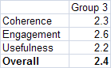

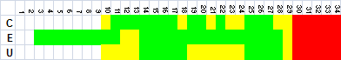
Overall scoring and heat map for Ames Group 3

Looking at the whole-session scores, the Overall score is lower than the highest-scoring group of the four Ames session (2.8), and lower than either Rutgers group, indicating some sort of trouble or difficulty during the session, although higher than the lower-scoring Groups 1 and 2. Particularly, the Coherence and Usefulness scores are low. Zooming in further, it is apparent from the heat map that timeslots 28-34 contain some sort of anomaly or event that caused the coherence, engagement and usefulness scores to drop to the Low level.

The CEU graph shows the drop in all three criteria as the discussion moved away from the map towards the meta-questions.

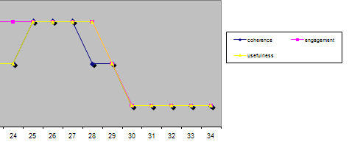
CEU Graph for sensemaking episode

The full CEU grid provides further detail on what occurred and the CEU ratings in each timeslot:

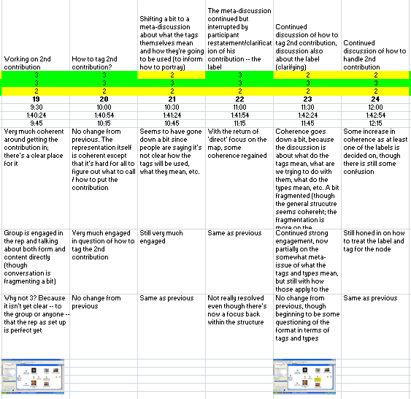
Full CEU Grid for Timeslots 19-24
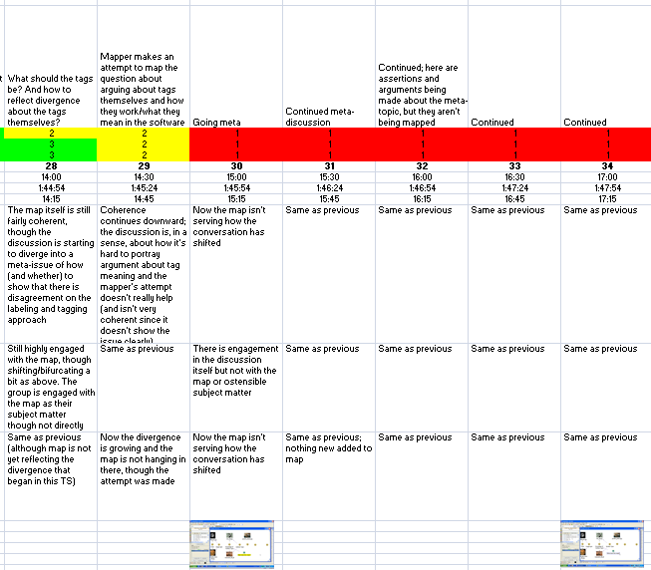
Full CEU Grid for sensemaking episode (28-34)

Narrative description of the sensemaking episode

There are really two sensemaking episodes I want to describe in this session, which in a sense are mirrors of each other. In both, there is a move toward a meta-discussion (meaning of tags, how are tags meant to be thought about, how to handle tags in Compendium; meta in the sense that it doesn’t have directly to do with the ostensible subject matter and form of the exercise). In the first occurrence (timeslots 19-24), it is handled and absorbed into the main thrust of the exercise and things keep going; in the second, at the end of the session in timeslots 28-34, the meta-topic assumes center stage and the practitioners are unable to rein matters back in (hampered largely by the switching of one of the practitioners from “facilitator” to “advocate/participant” for the meta-topic that he was championing.

In the first episode, the session is proceeding along its intended track and the group is working on the second contribution. All along there has been some confusion and discussion about exactly how to proceed, since the practitioner group had created a somewhat difficult structure to work in that required the participants to understand their complicated ideas about comparisons, choice of pictures, and tagging scheme, though it had been working along with lots of questioning and back-and-forth. In the midst of discussing how to label the comparison node (“surface conditions?” “Or how about knowledge of surface type?” “Could be both surface type and knowledge of surface type”), one of the participants starts to raise a meta-question: “So there’s an underlying question here.” He tries several times to intervene and get his question out in the forthcoming couple of minutes, e.g. asking again at V1:41:18 “And also what is the purpose of these tags? How are they going to be used?” which leads to the following interchange:

J. : Well that’s going to be determined by how we tag it isn’t it?
Mx: Ah exactly.
H: Exactly.
J. : Well that was the…
Mx: Well it’s actually y’know the what you typed there [pointing at screen] defines what you can answer as part of a node. [V1:41:30, C10:44] [end TS21]
J. : Yup. Yup.
Mx: Right? So what is the type of that question, of that light bulb. [V1:41:35] Is it a number, is it a symbol, is it a…
H: Um. What did we have it as? [V1:41:41] The type of the light bulb?

This might have derailed the intended thrust of the exercise (as it does at the end of the session) but things return temporarily back to normal when one of the facilitators (acting, as he tended to do, as a participant) returns attention to more direct matters (the text for one of the “comparison” node labels:

J. : Oh actually I didn’t say ‘has increased.’ It uh the lightbulb was supposed to be [Mi: Well…] just our knowledge of it. [V1:41:51, C11:05]

This leads the discussion back to direct engagement with the substance of the map and exercise. From then until the end of TS24, the discussion and attention is firmly on what to label the nodes and the tags, and which tag to give which node.

The interesting thing about this episode from a sensemaking perspective is how the proto-diversion is reabsorbed back into the main activity, fairly seamlessly. The mapper and facilitator do not have to strongly intervene to right the course; it occurs “naturally” in the course of discussion (aided by J. ’s correction move).

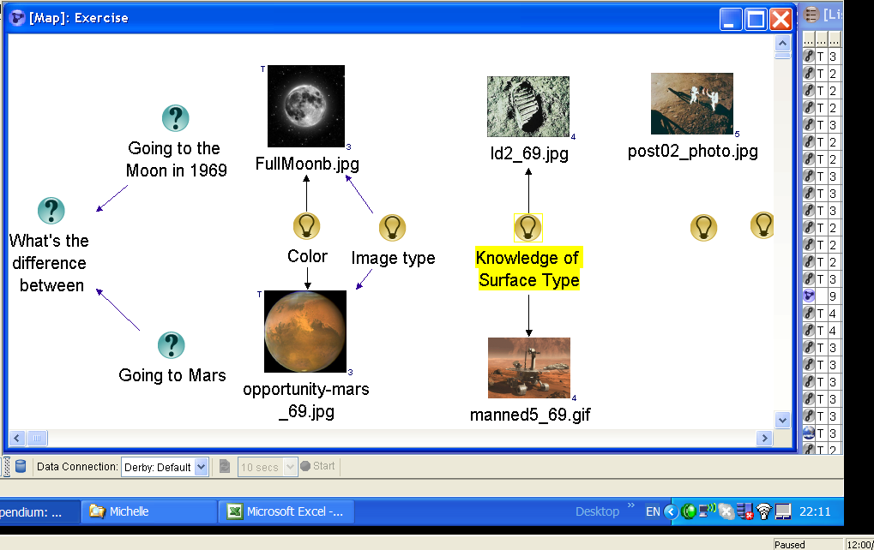
Figure 1: Map at C12:00, showing results of correction

In the second episode, the session does not recover from a resurgence of the meta-discussion. Here, the sensemaking trigger comes in the midst of a coherent discussion of how to tag the two “surface type” comparison nodes that had come out of the previous few moments. At C13:52, E sees an opportunity to ask his meta-question again, in a different form: “Well that’s so that’s a question so in this tagging exercise are we allowed to have alternative or opposing views? [V1:44:47, C13:58].” J. jumps right in, echoing this kind of question: “And if you have opposing views how do you do it there in the tag?”

At first, E’s question is absorbed in the discussion of how to tag the nodes:

J. : Well then so you get to come off of the Idea node about “knowledge of” with a question about what do you mean or whatever, I mean you can take this map any way you want to go. [V1:45:03, C14:14][end TS28 C14:15]
H? .. and where do you want to go…
Jc: Well it seems like, I mean, yes you can put it in a question hanging off of the …

But then another participant moves the discussion solidly in the meta-direction:

R: So far, I’m afraid, that we have introduced tags in such a way that you can’t question a tag. [V1:45:20, C14:31]

Unlike the previous episode, however, this time no one jumps in to revert the discussion back to direct engagement with the map. Instead, spurred largely by J. , one of the facilitators, switching to Dialogue / Participant mode, the discussion moves to the relatively abstracted topic of how to think about tags in general:

J. : That’s that’s actually so the tags themselves should be subjects and we would put, ideas and we should point to them, those tags. That’s a use case for Compendium by the way. [V1:45:29, C14:39]
H: Ohh…
J. : In other words there should be no un-subjective, there should be no un-objective [end TS29 C14:45] representation. Strings should be objects that can be argued about. [V1:45:41, C14:50]

What is striking about the rest of the episode (which continues until the end of the session at C17:15) is that neither the mapper nor the other facilitator try again to intervene to bring the discussion back to engagement with tagging or labeling. The mapper makes a silent attempt to create a node trying to mirror the discussion about how to show disagreement about tagging (the “What does this mean?” node and link in the screenshot below) but there is no verbal intervention, and J. , the other ostensible facilitator, is the most enthusiastic in the meta-discussion.

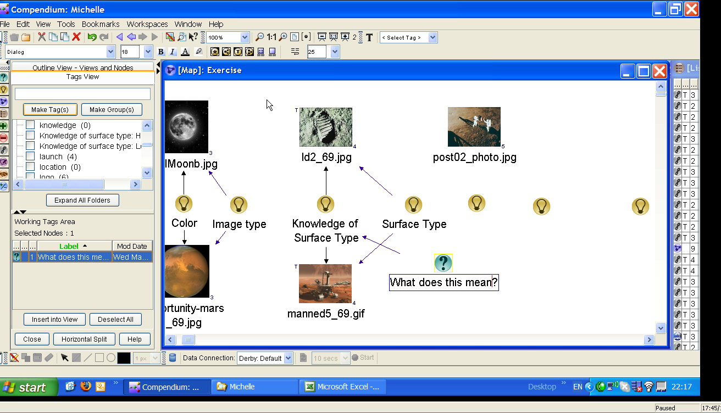
Figure 2: Map at C17:45

Framing the moves and choices

.
Element | Descriptive and normative questions
(A.1) Imposing their own coherence and values on a situation | - What coherence is the practitioner imposing on the situation?  As with the other Ames and Rutgers sessions, this consisted mostly of the pre-designed tagging exercise, which the practitioners mostly kept intact throughout the session. However there were divergent forces that emerged during the session, partially driven by one of the practitioners who essentially switched roles to participant/advocate for topics to his interest.  - What values is the practitioner imposing on the situation?  There was a value of diligence/completeness to pursue the exercise in its intended form, especially on the part of the mapper who kept asking for specifics on tags and labels even when the discussion seemed to veer into the more general or meta. The main facilitator seemed to be acting from a value of positive and enthusiastic support of the participants as well as the intended exercise, which extended to her seeming unwillingness to intervene when the meta-questions arose. The second facilitator seemed to be acting more from a “we’re here to investigate and discuss collaborative tools” perspective.  - In what ways are these congruent (or not) with those of the participants?  Both strains, judging by the amount of participation and engagement, resonated with the participants, though there was some tension or confusion about the form the exercise was to take.
(A.2) Constructing narratives to account for how the situation arrived at the current pass / breaches in canonicity | - What is the narrative the practitioner is using to construct the situation?  The intended narrative was the planned exercise, but there were also strains of the larger workshop setting (participants were there to learn about and discuss Compendium) which allowed for the meta-discussions.  - What is its degree of internal consistency?  It was consistent except for the meta-discussions that kind of drilled outward from the inside.  - How evocative and inclusive is it?  Generally the participants seemed to embrace the exercise, at least to engage in it and discussing it.  - How useful is it?  The usefulness was strong except when the meta-discussions occurred; the planned exercise neither contained nor explained such divergences.
(A.3) Eliminating prejudices and preconceptions | - What prejudices may be active?  - What preconceptions may be active?  There was somewhat of a preconception that the exercise would be clear or self-explanatory enough to allow unproblematic participation. Also that it was OK to diverge from the planned exercise if the divergence seemed compelling enough.  - What personal desires or goals may be active?  None detected, except for the personal desires to a) complete the planned exercise, or b) pursue interesting topics if/when they arose.
(A.4) Personal authenticity in the practice setting | - In what ways is the practitioner acting in an authentic manner (vs. received, affected, etc.)?  All practitioners seemed sincere and authentic in their actions.
(A.5) Mediated objects and other interventions should preserve openness and dialogicity | - How do the representations the practitioner constructs or modifies foster openness and dialogicity?  - How do they inhibit them?  The main form of the representation was given and pre-planned. Judging by the high engagement in them until the end, and the ease with which both direct participation and discussion/argument about how best to proceed, the representations did engender a good deal of dialogicity. However, in and of themselves, since they were intended to serve a particular purpose, they were not open in the sense that they could evolve in any possible direction.
(A.6) Artifacts should be clear, expressive, and helpful | - How clear are the artifacts produced/modified by the practitioner? How helpful are they within the context of practice?  The artifacts in this session have a two-fold quality. The structure brought in by the practitioners did hold up for the most part, but it took a good deal of discussion and questioning of what was intended and how to proceed for participants to engage in the way intended by the planners.  - How expressive are they?  It is not clear that the artifact produced was very expressive, given the difficulty many had with how to proceed, label, and tag. They were certainly evocative of discussion, but that was more a property of their lack of inherent clarity coupled with the density of the ideas and constructs represented.
(A.7) Perseverance in the face of checks and resistance | - What checks to forward progress does the practitioner encounter?  There are two main kinds of checks in this session. The first is the difficulty and partial confusion in just how to populate and proceed, as discussed above. The second is in the repeated digressing and “meta-ing” that characterized much of the session. Participants (and at least one of the facilitators) became more interested in discussing the meta-issues than in completing the exercise as intended.  - What resistance from participants, materials, etc. occurs?  The density of the comparison, labeling, and tagging approach planned by the practitioners appeared to create some resistance. Participants could be said to have (to some degree) resisted being pulled back to the planned exercise when the meta-issues arose, since it felt important to them to discuss them (in fact, the discussions arose because the materials and process did not feel clear or easy, so it was necessary to question and discuss to be able to proceed).  - How does the practitioner respond in the face of these?  There were several types of responses, ranging from persistence/diligence on the part of the mapper, clarification/invitation/agreement on the part of the main facilitator, or more acting-as-a-participant on the part of the other facilitator.
(A.8) ) Clear and focused communication | - How clear is the practitioner's verbal communication?  The three participants had three different styles of verbal communication. The mapper’s style was very focused on the details of completing the exercise, clear as far it extended (repeated asking for which tags, labels, etc.) The main facilitator was also clear and positive, taking an emcee role for the most part, using verbal interventions to maintain a tone throughout until seeming to give up at the end. The other facilitator was more abstract and more willing to diverge into meta-topics.  - In what ways does the practitioner maintain focus on the aspects of importance in the situation?  Both mapper and main facilitator worked hard to keep the focus on the intended exercise, helping participants to engage and work through the intended contributions, successfully keeping things on track until the end. The second facilitator, however, jumped to and on meta-topics several times.
(B.1) The importance of participants' impulses and desires; attention to what may be bothering or affecting participants | - What observable or discoverable participant impulses, desires, or other factors are operating in the situation?  Several of the participants had a seeming strong desire to make sense of the structure provided by the practitioners by discussion how it could work, and the implications of the structure and the exercise for meta-topics.  - How does the practitioner address these?  The main facilitator tried to include and go with these issues for the most part. One participant,. E., tried several times to voice his (meta-) concerns and questions but they were not heard or addressed directly.
(B.2) Unfinalizability; preserve room for surprise, imagination, and creativity to emerge | - In what ways do the practitioner's actions reflect an attitude of unfinalizability toward the participants and their interests, concerns, and agency?  The main practitioner attempted to be inclusive in her tone and actions. Although she also tried to keep things going on the main exercise, she made answering comments to most entries and did not rule out contributions. However, there was no attempt to include them in the representation itself (this isn’t a bad thing, but the direction might have been to capture such ‘off-topic’ contributions somewhere then return attention to the main direction).  - In what ways does the practitioner preserve or close off room for surprise, imagination, and creativity to emerge?  By listening to and directly incorporating participant input into how to capture elements of the main exercise. Most of the way the tagging and node additions/labeling occurred was due to the way the practitioners incorporated participant input into the map.
(B.3) Dialogic orientation | - How do the practitioner's actions and communication open up or close off dialogue in the situation?  - In what ways does the practitioner display openness and sensitivity to the different participant voices (vs. summarizing them into abstractions or types)?  Mostly see B2. An additional note: there were several times when many people in the session were talking at once, and not all of those threads were captured and included. But this was due less to practitioner action than simple pressure of time.
(C.1) Heightened degree of connection between people, setting, purpose, and medium | - How do the practitioner's actions help create this kind of connection and integration?  See B.2. The main facilitator’s attempts to be inclusive and welcoming of participation aided this, though in such a short session there is limited opportunity. The second facilitator’s pursuing of side issues could be seen as an attempt to broaden the discussion to topics of more general interest to at least some of the people and event, but it detracted from the purpose and medium (mapping representation) in this particular setting.  - In what ways are the distinctions or boundaries between people, setting, objects, etc. made stronger or lesser?  .
(C.2) High level and quality of communication | - How does the practitioner elevate (or diminish) the level and quality of communication in the practice setting?  Nothing different to say here than in B.2.
(C.3) Importance of the past as the background and context to the practice setting | - In what ways does the practitioner reference or bring in elements of past work, ideas, or events?  - Are such "background" elements combined with "foreground" (current) concerns, ideas, or representations?  The main facilitator makes references to the space program and its place in popular culture, taking cues from participant contributions, but these don’t find their way into the representation.
(C.4) The relationships of parts to parts and to the whole | - How does the practitioner focus on both individual details and the relationships of those details to the 'big picture' and each other?  The “big picture” that emerged in this session had to do with the meaning of tags and how the kinds of comparisons and relationships intended in the exercise could be represented. There was a good deal of verbal discussion on this theme that the practitioners engaged in, though the only reflection of it in the representation was the sidebar “What does this mean?” Question node added at the end.  - How are the moves from parts to whole accomplished?  Through a combination of participant and facilitator verbal interventions and statements, but the tension between what was really a meta-issue and the intended exercise itself was never really dealt with head on. The representational framework provided by the practitioners more or less dictated how the “parts” and “whole” would be portrayed, leaving unspoken the questions that kept emerging about what “parts” such as the tags would really be used for in the “whole”.  .

