Ames Group 2

Rough transcript, Ames group 2 large group session

[Timings are from camcorder video, which starts at 51:30; where 2 times are shown as XX/YY, XX is from the Camtasia recording, YY from the camcorder video]

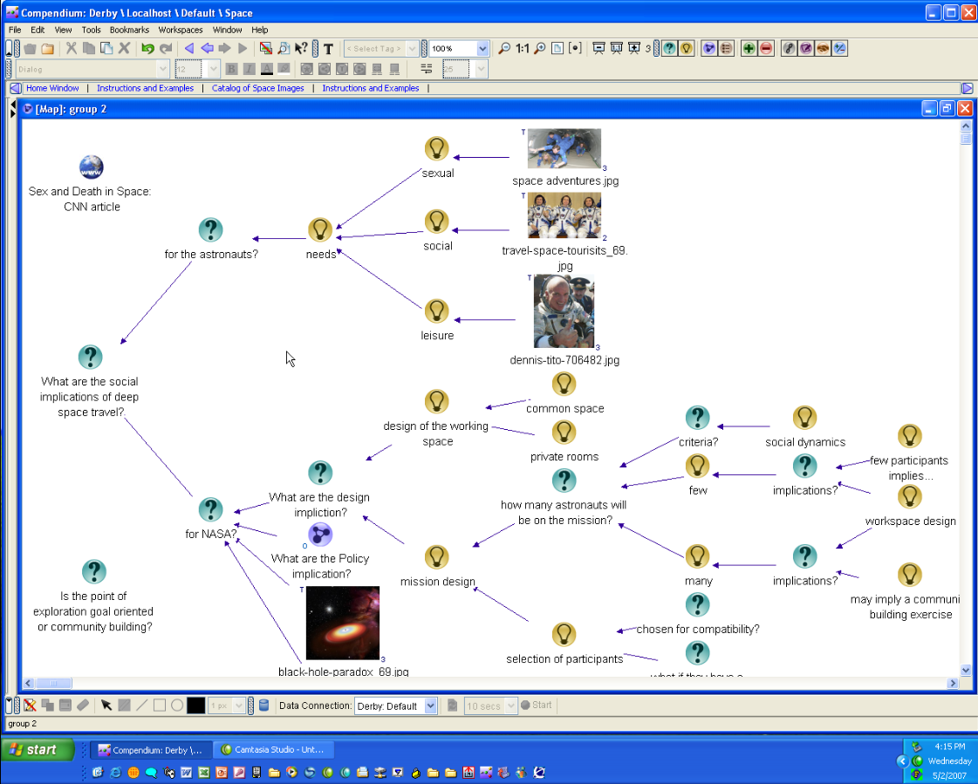
Screen before start of session

E. gives a general intro from 51:30 to 54:00.

A. starts an intro and walkthrough of the map at 54:11.
She explained the map to “make it more deep and rich for you.”

A. finished her walkthrough of the map by giving the following instruction to the large group: (57:53) “The main question I want to ask you is, if you think, two main questions, the first one is which one of all this [gesturing at the map], implications, do you think are important, and which are the priority for example if you think they have to be taken in consideration or not, and then we can choose to go deep into the map and specify this kind, this different, implication, or for example, we can decide to go back, and to understand if, and why, this, uh, social implication are important, and has to be taken in consideration, so…[raises arms and lets flap to her sides] Now is the moment for your ideas [laughs].”
(58:38)

[A participant (J2) made the first comment, criticizing the map’s structure]

J2 (58:43): “I’d like to ask a question, and I, Jeff help me out here, I can’t remember whether this is a deontic question or not, but that word comes to mind and I thought I’d use it for the fun of it. It has to use with the ontology that you’ve used in the nodes. Now if you could scroll up higher… I’m going to be known as the group antagonist for the moment”

J: “That’s R..…”

J2: “I’m going to take a little of his thunder, so, so you said needs and then you said sexual social and leisure, and I just have this sense that sexual and leisure are, are fairly closely aligned as in related to each other in some sense sub-class super-class, or, they don’t belong separate in, in my view…”

- “OK, …”

J2: “…so it’s caused a sort of cognitive dissonance (59:28) looking at your map [gestures at screen] … so I’ve, I feel like arguing with you about that.”

[This could have been a good moment to recraft the map, or try an alternative mapping]

M: “And they’re all social.”

H: “And I was going to say they’re all both leisure and social.”

J2: So, so, … yeah! So the point is [still gesturing at screen] is that”

A: “So do you think that there are some other kind of leisure that can be considered part of …”

J2: There’re other kinds of leisure as well …”

L: “And I don’t think sexual has to be social or leisure.” (59:57)

[…similar stuff skipped…]

J2: (1:00:03) “But we have to be careful here we’re in polite company here. The point is that [laughter, other conversation] (1:00:09) I’m choosing my words here very carefully. The thing is that that I see sexual as being bifurcated into both the procreation, and the leisure [gesturing to indicate the relationship he sees between the two concepts]. Now those two can go together as well, but I’m saying they really are two branches of, of, of the nature of sexuality and sexual practices and so forth, and I’m just having trouble seeing sexual and leisure so far apart in your map.”

A: “Yeah. OK.” (1:00:34)
[Said as if she was going to do some facilitation or direction, but yields to the next participant statement]

M: (1:00:34) Well I I would say it’s perfectly fine not to have a, the correct ontology. It is just that they uh have a position, about needs are sexual needs, and so that means needs to have sexual contact, sexual physical contact, and the needs to be social in terms of having a party, or just being together, or y’know just in close proximity, but not, not having sex. Right? And then, leisure being listening to music, uh, reading a book, y’know, so if you categorize them in that way, it’s fine to have them separate.”

[This could have been captured on the map as clarifications of the nodes, either as linked nodes or in the detail of each. What I want to do is somehow characterize that there were many opportunities for things that could/should’ve been mapped, opportunities to have engaged the group in the mapping of these challenges and suggestions – that those were (or could’ve been) cues for the mapper or facilitator to do so, but they were missed, with no alternative strategy followed except the surfing of the verbal conversation]

[At 18:00/1:01:10, JP tree-highlights the section being discussed]

L: (1:01:13) Well isn’t the larger question how, how we have whatever a normal life is, on, on earth, and it usually involves, you know you might as well add [emph added] psychological needs, I mean what happens when we’re separated from just dirt, or earth, or plants, for three years and so we have whatever is quote unquote normal human existence, and and basically how careful are we transfer that normal human existence to a three year space travel, and, y’know.

A: (simultaneous with “and” above) “Yeah. Yeah well…”

J. then makes a verbal intervention:

(1:01:39) “I think that all of those are points well taken and can be, you can massage this section up here… but the section up here is really driving the true point for us which is down here. What are the implications for NASA and how they design everything else? So yes I agree with all of those points up here there could be more needs, these things could be grouped underneath one another, stuff like that. Um but where we were going with that was, all of this stuff down here, and what are the social dynamics of, say, what are the implications of having just a few people on a spacecraft versus having many. How does that impact not only the design of the mission, are you trying to do a community-building thing out in space somewhere. Um, and what are the implications of too few participants off in space for four years.” (1:02:26)

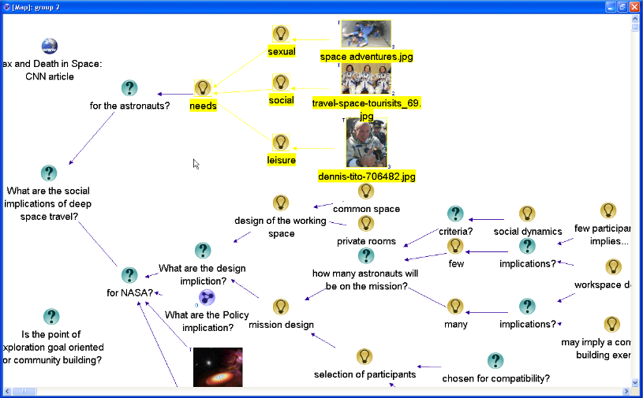
(Map at 18:39:49 (Camtasia timing), showing that J had highlighted the area under discussion during his speech above. He rolled the cursor around in the lower area while he was talking, but did not highlight any other area).

[Talks about the map, even directs attention to different parts, but actually deflects the participants from engaging with changing the map, and also deflects the suggestions and changes that the participants were making; tries to get the group back on his/Group 2’s desired agenda]

A: (1:02:29) “Yeah so …” [starts to say something but then abandons]

M: Yeah so I could take a NASA position. … (1:02:31)

J: “OK”

M: (1:02:33) “Which has been taken in the past, and that is [looking at the map]… these social needs, or these needs, are unimportant for the design of the spacecraft. What is important of the design of the spacecraft, craft is physics, and how do we survive. The rest is irrelevant.”
(1:02:51)

E: “That’s not… d’you think that applies for a three-year space mission? ‘cause…”

M: (1:02:55) “Well… I’m just saying that is a position to take. That’s the position that NASA has taken.”

E: So, so current NASA criteria for designing a spacecraft is survival, and what was the other thing?

[someone] “And physics.”

M: “And physics.”

E: “Survival and physics.”

J2: (1:03:10) “But survival’s only…”

M: “But physics relates to budget. Money.”

E: “Survival… physics…”

A: “But do you think that the physics for one person can be in a way affected from his uh social condition…”

[This intervention is ‘discussionish’ not ‘mapish’; she doesn’t make reference to the map, but just to the subject matter]

[at 20:20/1:03:25 JP moves around the map as if to look for a place to capture M’s points]

M: “Well no what I mean is, what I’m saying is that they don’t take the social aspect of the astronauts into consideration when they’re designing a spacecraft.” (1:03:30)

L: “And they wouldn’t consider that um social or like let’s say mental and emotional well-being might actually contribute to the survival of the”

[around this time, J adds a new Question node “criteria?” and links it to the “For NASA?” question ]

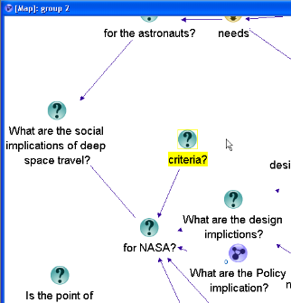

M: “Well no so there has been lots of studies going from the MER mission to the y’know uh from Skylab, so they have, they have experience you know in Skylab the the the crew, um, well how do you get it, did a mutiny. They, they stopped listening for a couple of days to mission control. They uh stopped communicating.”

[(starting at 20:35/1:03:36, finishing at 21:05/1:04:02) J adds two Answer nodes, “physics” and “survival” which captures the high level of what M has been saying]

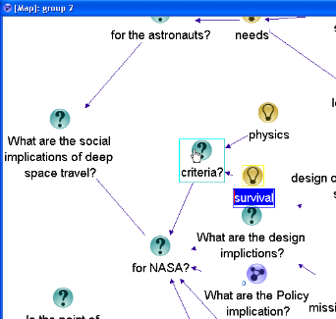

[does an Arrange, then adds “budget” linked to “physics”]
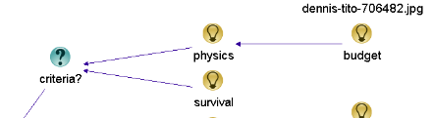

[A bit later (22:20/1:05:15), adds the Answer node “none. NASA doesn’t take astronauts personal needs into consideration” and links it to “What are the design implictions?”; summarizes M’s points, but no reflection/ validation etc.]

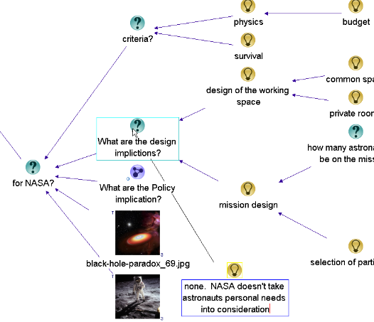

E: “Why?” (1:04:01)

M: “Because they just were sick of ‘em…”

E: “They were just sick of ‘em?”

M: “Yeah.”

J3: “Well you know the beauty of this example you point out is that it shows the danger of NASA’s engineering-oriented, narrow-minded view of human existence.”

J2: “Oh, so now it’s a political matter.”

J3: “That it’s a…so it’s a if it’s really about physics and survival, then there’s a whole dimension of human interaction…”

M: “Right so…”

J3: “…human communication, paying attention to people who’re saying maybe that O-ring’s not so great, this whole dimension that’s getting neglected systematically in the design of missions.”

M: “Right. And so this is a big struggle cause they know if it’s for three years and they know they won’t be having control in mission in Houston, the astronauts will be in control, this is suddenly changing the whole paradigm. But, y’know, how to deal with this is not very clear.” (1:04:54)

J2: “Yeah, so…”

M: “And there are a lot of examples of expeditions to the north pole and south pole and y’know what happened there and y’know how people so, so, so it’s not clear also that even designing, that you can design this…. At all.” (1:05:12)

J2: “So the suggestion here that you’re saying is that in fact the question “For NASA?” question mark is really the wrong question to be asking. It’s really for the astronauts.” (1:05:22)

[gestures at the screen, he’s talking about the the node; not picked up on by facilitator or mapper; bold indicates that was another moment where the participants were engaging with, or at least referring to, the map]

M: “Well so for NASA astronauts are just robots. They’re just, y’know, they’re like resources that use up oxygen. Actually they’re expensive resources … oh shit we need to deal with them”

J: “I’m fragile”

M” …y’know I wish we didn’t have so many difficult astronauts.” [laughing]
(1:05:44)

A: (1:05:44) “But do you think that if there were some evidence of the things that giving to the astronauts a better environment in terms of of giving them a real community in the space they could take in consideration it into the design of the mission? Or do you think that they will be ignored.”
(1:06:10)

[again a discussion-ish move, no reference to the map]
[at 23:05/1:06:05, JP creates Answer node “Astronauts are robots”, again summarizing part of the discussion, but no reflection or engagement – does there need to be? That is a different question, but in this case it was the explicit assignment]

M: “No they definitely wouldn’t be ignored.”

[Timekeeper announces one minute left]

A: “OK. So we have one minute. [laughs]

J2: “No. We’re not done.” [laughing]
(1:06:24)

A: “So [turns to look at the map briefly] I was just, uh, to ask you, your point of view, not so only the NASA one. But, do you think that for example [turns to map] is an important point to consider the astronauts in this kind of mission also in uh in terms of human being and so consider him like a, a person? And giving him the same right in terms of uh social, and leisure, and any kind of uh community needs, or not. And which kind of uh y’know uh of needs do you think are the most important like for example, yes, OK, with the social space. Or OK with the leisure spaces, but maybe that are not sexual implication between the astronauts. Also a different kind of uh choices can be done into the same points.”
(1:07:28)

[no place for participants to break into that]

[during this speech JP creates Con node “does this attitude hurt the mission”, which he refers to verbally following]
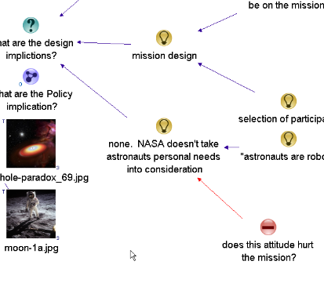

J: (1:07:34) “I think it’s kind of fascinating that we being not NASA people would come up with all this stuff and then hearing from the inside makes me wonder does this attitude hurt the mission?” (1:07:39)

[Kind of like a private version of the map, deciding what is significant and what isn’t; summarizing only MXS comments, not anyone else’s or A.’s]

Screen at end of session:

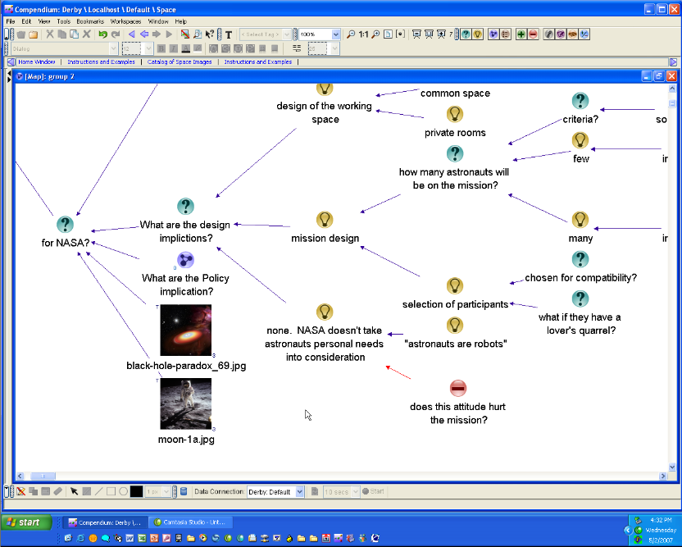

Informal analysis

What’s interesting about this session is that in some ways it’s a failure. The group had a reasonably good discussion about the chosen topic, but failed to get anything significant on the map. What was put there was done as after-the-fact notes chosen by the mapper (very selectively; only 6 nodes were created during the session) without any validation, or direct engagement with them of any kind, invited or provided by the facilitators. A. and JP did both gesture at and refer to the map a few times, but never got the group to focus on it, either by bringing them into an effort to make a change to it or asking for validation for the few nodes that JP did create.

A and JP kind of treated the map as if it spoke for itself, a self-sufficient artifact of the prepped conversation they had had about the CNN article. They did provide somewhat vague invitations to the group to “enter into” the conversation as it had already been mapped, or to comment in some unspecified way about the distinctions they had prepared, with an unclear directive to say what might be important or prioritize what was already there.
Somehow the conditions for successful engagement with the artifact were not met. Too much information, unclear actions, and then the very first thing that happened was a challenge to the structure (from J1) that the facilitators did not directly respond to (although (a) A. did seem as though she was going to respond in some way, then allowed others to interrupt her and did not return to her response, and (b) JP referred to the challenge and highlighted the nodes being discussed, though did not make any changes to the map itself and indeed said that the challenge and the discussion around it were not what they were looking for).

It seemed they wanted to steer the conversation in the direction of “what are the implications for NASA of looking at the social dimensions of eople in space, and which should be most important.” But that never happened in the session, per se. Instead there was a very clear challenge to a small portion of the pre-existing map’s structure from J and others, who talked about how the way the “for the astronauts?” section had been “broken up”, mapped in a way that didn’t feel right. There was some back and forth among the participants on that for a while, but it was negated at 1:01:40 by JP’s comment that while the section could be mapped differently and that the participants were making good points, “the true point for us… is down here” pointing to the lower section of the map. No direct invitation or activity is invited or created. Instead, M makes a new verbal contribution which could also have been mapped (a small piece is, later), or made an explicit clear focus for mapping, but instead takes place just as a verbal conversation. [should also poiojnt out that tht etwo introductions poured too much information about topic/subject matter and not enough about tasks/activities to do in the session]. It’s not until 1:05:22 that someone makes a reference to the map again, challenging the “For NASA?” Question – which again, could have been taken up but was the second “missed opportunity” in the session. The facilitator makes a verbal intervention, but it’s only on the topic/subject matter level, with no reference to the map, either how it/s already mapped or how it could have been changed to incorporate the previous discussion.

That brought the session to 1 minute left. A. tried to restate the facilitators’ goal of getting participants to consider the importance of social/human needs and which are the most important, but she talks for over a mnute of directions that used up nearly all the remaining time.

There can be said to be four major phases of the session:

- Intro
- Challenge to the structure (“cognitive dissonance”)
- “Physics and Survival” discussion
- Last minute

In both (2) and (3), participants did make actual references to the map’s content and structure, questioning and arguing with it, but no uptake by the facilitator or mapper in bringing those into the map, or mapping process. Instead they held to their stated purpose, but never have, or helped give, the participants a way to actually do it or perform it on the map.

So in terms of sensemaking moments/triggers, the two that are most significant are:

- J2’s challenge to the structure followed by the clarifying discussion than the JP move at 1:01:40. It’s a steering, re-orienting move that actually fails, at least in terms of any map-building [could talk about what moves might have taken place]
- J3’s attempted reframing of one of the pre-existing map questions at 1:05:22, that is not taken up – just swept into the ongoing roll/flow of the discussion

Somehow need to account for what I’m saying is the overriding imperative – to build up the map, or at least make it a focus (if not the focus) of the effort – the criticism would be, well, why does it have to be on the map? Didn’t the group have a good discussion anyway? The point really is that here are the types of dynamics – and facilitator moves/choices – that do happen and resulted, in this case that the map didn’t become a focus of activity, a “direct manipulation” group artifact. Was the map not at all useful? No, it was a bit useful because it certainly served as a springboard for discussion. But if the imperative is to make it an actively engaging, useful artifact, these kinds of actions/choices/lack of action are the kinds of things that can prevent it.

You could easily imagine (as was in fact discussed in the debrief following the session) mapping out the objections, putting on new map, etc., taking advantage of the hypermedia aspects – but none of that was done so the session didn’t go anywhere, at least in terms of map-building.

Invitation: Which of all the pre-mapped implications are most important, and what further implications can be specified?

Challenge: I don’t like the way you’ve mapped out one area of the implications (focus in on that area of the map)

Response: I can see what you’re saying, but reshaping it is not what we wanted to do, rather we want you to focus on this other question.

Notes from Debrief session

There was a ‘master class’ debrief session after the session. The following were proposed as to what might have gone wrong:

- roles unclear (identity confusion, who are we?)
- the whole setup (of the experiment as a whole) was an artificial situation
- the map was too busy, where are we supposed to look
- A didn’t know how to moderate, “I was not able to reach my main objective”
- Theme was unclear
- The main idea of the prepared map was “challengeful” and difficult
- Map was already constructed instead of building it on the fly
- Font was too large to see much of the map at once
- I didn’t like the map so I vented(?) it…
- The participants didn’t own the representation
- “what setting is necessary before this tool can be used productively?”
- “I didn’t feel engaged at all with the map”
- “Most of us were just focused on the people and the conversation”
- “What would’ve helped would’ve been for you as facilitator to be pointing at the map and drawing our attention to the areas of the map he was entering things into so we could see our inputs being incorporated into it”
- The facilitator took too much stake in the map as it was, didn’t create space for the objection
- “If you’re not directing people to look at the map, what’s the point of the map?”

