Sensemaking Moment Analysis: Ames Group 2

Overall CEU scoring table, heat map, and CEU graph

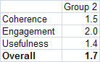

Overall scoring and heat map for Ames Group 2

Looking at the whole-session scores, the Overall score is the lowest of all Ames and Rutgers sessions, indicating some sort of trouble or difficulty during the session. Particularly, the Coherence and Usefulness scores are low. Zooming in further, it is apparent from the heat map that timeslots the session from Timeslot 10 on ran into trouble, causing coherence and usefulness scores to drop to the Low level.

This gives context for the finer-grained analysis of what happened in timeslots 10 through 16, the trajectory of a complete “sensemaking episode” starting with a trigger and ending with the (partial) resolution.

The CEU graph shows the drop in Coherence (blue) and Usefulness (yellow) as the mapper struggles to get back on track during the sensemaking moment.

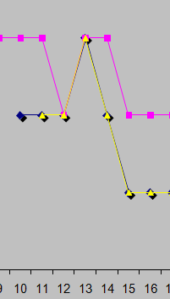
CEU Graph for sensemaking episode

The full CEU grid provides further detail on what occurred and the CEU ratings in each timeslot:

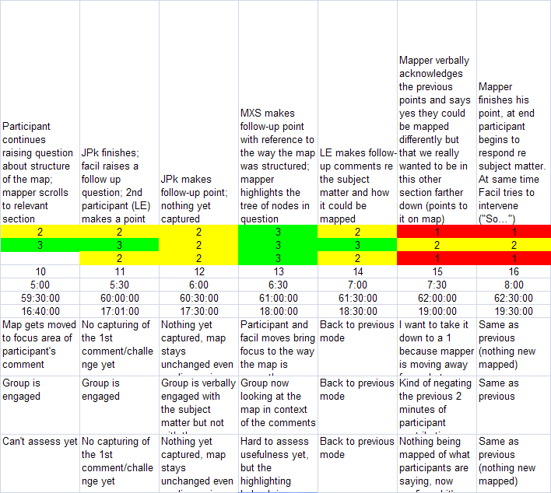
Absolute and relative timing (bottom two rows are timings from Camtasia and video recordings)
General descriptions of the activities in that timeslot
CEU ratings for each timeslot
Usefulness descriptions
Engagement descriptions
Coherence descriptions for each timeslot
Full CEU Grid for sensemaking episode

Narrative description of the sensemaking episode

The instance occurred for about 3 minutes 44 seconds of the 15-minute session, starting at TS10 and lasting until TS16. The facilitating team had constructed a knowledge map with a seed dialogue. [See AmesGroup2ShapingForm.docx for more description]. One member of the team acted as facilitator, and one as mapper.

After the facilitator had given a rather lengthy description of the prepared map, focusing on its subject matter (this intro lasted for more than 4.5 minutes, almost a third of the allotted time for the session), she asked the participants to begin contributing: “Now is the moment for your ideas”.

Immediately J2, a participant, raised an objection to the way several of the ideas were mapped in the prepared map. He referred to a specific section and objected to the way the concepts “sexual” and “leisure” as needs were configured in the map, stating that “they don’t belong separate in, in my view…” Several other participants joined in, saying that they did or didn’t agree with the objections, all referring specifically to how the ideas appeared on the prepared map. The facilitator made a couple of brief attempts to draw the discussion into the intended fleshing-out of the prepared map (“So do you think that there are some other kind of leisure that can be considered part of …”), but the participants continued to discuss the specific map area and whether or not it was captured correctly, also making suggestions for augmenting the mapped concepts in that area (“you know you might as well add psychological needs”).

There is sensemaking going on here on several levels: First, the participants themselves are trying to make sense of the map and appropriate the prepared material into their own understanding, even going so far as to point out specific things they don’t like or would like to add. Second, and for our purposes the central point, the practitioners see the session veering off from their intended direction almost from the very start and have to come up with a response.

So the trigger was the veering off, led by J2’s comments.

At 2:54 into the episode, J, the mapper, intervened in this discussion by making the following statements and software moves. He had already highlighted the area on the map that J2 and others were discussing, and now he points at it with the cursor while stating that the conversation should move off the points that the participants were making, and back to the intended direction, symbolized by the nodes and links in the central area of the map:

“I think that all of those are points well taken and can be, you can massage this section up here… but the section up here is really driving the true point for us which is down here. What are the implications for NASA and how they design everything else? So yes I agree with all of those points up here, there could be more needs, these things could be grouped underneath one another, and stuff like that. Um but where we were going with that was, all of this stuff down here, and what are the social dynamics of, say, what are the implications of having just a few people on a spacecraft versus having many. How does that impact not only the design of the mission, are you trying to do a community-building thing out in space somewhere. Um, and what are the implications of too few participants off in space for four years.”

While saying this, he uses the cursor to point at and circle the areas of the map he wants the participants to focus on.

In his response, J2 acknowledged different mapping possibilities that would incorporate the participants’ statements (“So yes I agree with all of those points up here, there could be more needs, these things could be grouped underneath one another, and stuff like that”). However, he does not perform any of these, instead directing the group to focus on the intended area (“all of this stuff down here”).

As soon as he finishes his statement, the facilitator attempts again to intervene (“Yeah so …”) but is interrupted by another participant, M, who takes the discussion off in another direction. The session continues, but there are no more attempts by participants to engage with or influence the form or content of the map (instead, the session becomes a typical discussion, with no reference to the map itself).

[Note: there are other responses the practitioners could have made, some of these are discussed in the Shaping Form, but our main concern here is the specific choices they did make and what the consequences were].

Framing the moves and choices

In this excerpt we see the mapper take control of the flow of discussion by making a verbal statement and pointing at the area of the map he wanted the group to focus on. This was caused by a “veering off” of the intended flow of events into a different sort of conversation and engagement with the map.

Element | Descriptive and normative questions
(A.1) Imposing their own coherence and values on a situation | - What coherence is the practitioner imposing on the situation?  In this case the mapper imposes his view of how the session should proceed, rejecting the implicit direction arising from the participants’ discussion. This was based partly on the plan the facilitating group had developed beforehand, and partly on his own sense of coherence (since the group had not specifically planned or agreed on what each practitioner should do, or what to do if something like the triggering event occurred.  - What values is the practitioner imposing on the situation?  In such a short example it’s hard to determine values, but it is apparent that the mapper felt the intended discussion was more worthwhile than the turn that J2’s challenge was taking things.  - In what ways are these congruent (or not) with those of the participants?  The participants appear to want to explore and direct the form of the map itself, which is not congruent with the mapper’s and facilitator’s desire to keep the session on the intended course.
(A.2) Constructing narratives to account for how the situation arrived at the current pass / breaches in canonicity | - What is the narrative the practitioner is using to construct the situation?  There is the ‘story’ that the practitioners had composed in their planning session, and partially expressed in their map – that there would be a generative discussion on the theme of what NASA should do w/r/t the design implications of the social dimensions of deep space travel. To them this was a coherent and compelling “mission” based on a well expressed map that would draw the participants in and yield new insights that could be added to the map. The mapper’s move was intended to draw the participants back into the intended narrative flow. The “breach narrative” was one of “you guys are going off course, looking in the wrong place and talking about the wrong things; I’m going to gently but firmly guide you back.”  - What is its degree of internal consistency?  Based on the map and discussion during the session (and borne out by the participant comments in the debrief afterwards), this narrative’s consistency was not apparent to the participants. The form of the map was too busy and scattered to convey the intended form and content of the session, and the instructions from the facilitator and mapper (as well as the introduction from E.) did not convey the consistency.  - How evocative and inclusive is it?  The intended narrative could have been both, and it did generate an active discussion. However, not as expressed in the map itself or via engagement with the map.  - How useful is it?  This question may need revisiting – I guess “it” refers to the practitioners’ narrative frame, and in this case, it proved to be not all that useful in terms of generating engagement with the map. Part of the frame was that the map itself would serve as a sufficient trigger for engagement and discussion – it worked for discussion, perhaps, but not for engagement with the map itself.
(A.3) Eliminating prejudices and preconceptions | - What prejudices may be active?  Two that I can detect: A prejudice toward IBIS/dialog mapping as the general approach – that it will be generative in and of itself -- and towards the compelling-ness of the subject matter and prepared map as the spur.  - What preconceptions may be active?  Similar to prejudices – a preconception that the discussion will unfold in a certain manner. In their planning session, the practitioners spent little time thinking about the process.  - What personal desires or goals may be active?  A goal to have the discussion unfold as planned/desired.
(A.4) Personal authenticity in the practice setting | - In what ways is the practitioner acting in an authentic manner (vs. received, affected, etc.)?  There’s no evidence of any lack of authenticity on the part of either practitioner. They both seem to be acting in the moment and sincerely trying to foster a good discussion.
(A.5) Mediated objects and other interventions should preserve openness and dialogicity | - How do the representations the practitioner constructs or modifies foster openness and dialogicity?  In this case it is more about the representations that the mapper did not create – that is, none of the participant contributions were mapped or reflected on the map. Highlighting the “needs” section while participants were talking about it did, however, at least acknowledge the current subject of discussion until the shut-off move.  - How do they inhibit them?  The prepared map appeared (and was said by participants afterward to be) too complex/involved for participants to engage with, although the mapping of the “needs” section did seem to invite dialogue (unfortunately shut off by the mapper). The mapper’s verbal intervention served to inhibit the nascent discussion about how to map the “needs” section.
(A.6) Artifacts should be clear, expressive, and helpful | - How clear are the artifacts produced/modified by the practitioner?  As discussed above, neither the prepared map nor the additions made from time to time during the session by the mapper contributed much clarity to the session. Participants commented afterward that they weren’t able to follow the map, and turned away from it. The additions during the session were minimal in nature, though well formed and clear as far as they went.  - How expressive are they?  The prepared map contained a good deal of information about the topic, so thus could be said to be somewhat expressive (though this was obscured by the density of the display and lack of clarity). The additions during the session were minimal in nature, though well formed.  - How helpful are they within the context of practice?  Not very helpful in this instance.
(A.7) Perseverance in the face of checks and resistance | - What checks to forward progress does the practitioner encounter?  The practitioners encountered what appeared to them as a “veering off” of their intended course for the session. They intervened within a couple of minutes to provide what they felt was needed correction.  - What resistance from participants, materials, etc. occurs?  The participants voiced immediate resistance to the form of part of the prepared map.  - How does the practitioner respond in the face of these?  As documented in the sensemaking instance write-up.
(A.8) ) Clear and focused communication | - How clear is the practitioner's verbal communication?  The mapper’s verbal communication during the incident is very clear. The facilitator was not as able to get her meaning across or effectively guide the discussion (as she later described in the debrief).  - In what ways does the practitioner maintain focus on the aspects of importance in the situation?  (This question should be revisited also, I think.) The practitioners in this case felt they were doing just that by intervening to get the discussion back on track. But, after that intervention they did not successfully move the session in the direction of engagement with the map.
(B.1) The importance of participants' impulses and desires; attention to what may be bothering or affecting participants | - What observable or discoverable participant impulses, desires, or other factors are operating in the situation?  In the sensemaking instance, there was a strong impulse on the part of J2 to make the map cohere to his mental model of how the concepts relate to each other. Otherwise, the observable impulses were a collective strong desire to talk about the subject matter itself and debate the various ideas about NASA’s position on astronaut needs.  - How does the practitioner address these?  Re the sensemaking instance, the mapper actually thwarts J2’s impulse. Otherwise, by letting the discussion more or less happen without further intervention, the practitioners mainly let the participants talk as they wanted to.
(B.2) Unfinalizability; preserve room for surprise, imagination, and creativity to emerge | - In what ways do the practitioner's actions reflect an attitude of unfinalizability toward the participants and their interests, concerns, and agency?  Really this doesn’t happen in any explicit way in this session. One could say that by not constraining discussion after the sensemaking instance (where creativity/surprise was in a sense clamped off), such room was preserved, but that is a stretch.  - In what ways does the practitioner preserve or close off room for surprise, imagination, and creativity to emerge?  The mapper’s intervention at 2:54 closed off the nascent spontaneous direction that J2 and others were following.
(B.3) Dialogic orientation | - How do the practitioner's actions and communication open up or close off dialogue in the situation?  The mapper’s intervention closed off the incipient dialogue emerging around “types of needs” by explicitly saying that’s not what the session was meant to focus on, and by not capturing or mapping any of that conversation.  - In what ways does the practitioner display openness and sensitivity to the different participant voices (vs. summarizing them into abstractions or types)?  No summarizing into abstractions or types occurred per se, but the mapper’s intervention placed the J2 and other voices in a “not allowed” type.
(C.1) Heightened degree of connection between people, setting, purpose, and medium | - How do the practitioner's actions help create this kind of connection and integration?  This did not occur during this session.  - In what ways are the distinctions or boundaries between people, setting, objects, etc. made stronger or lesser?  This did not occur during this session.
(C.2) High level and quality of communication | - How does the practitioner elevate (or diminish) the level and quality of communication in the practice setting?  By shutting off the discussion at 2:54, the mapper arguably diminished the level of communication that could have occurred. While the discussion that followed was animated, it did not include any engagement with the map itself, which arguably reduced the level/quality of communication.
(C.3) Importance of the past as the background and context to the practice setting | - In what ways does the practitioner reference or bring in elements of past work, ideas, or events?  When the mapper intervened, he did so by pointing to the elements of the pre-made map that he wanted to the group to focus on, and verbally invoking the intended direction and focus for the discussion and how it related to those map elements. But these were “foreground” not “background” elements.  - Are such "background" elements combined with "foreground" (current) concerns, ideas, or representations?  Background elements were not really involved in this session.
(C.4) The relationships of parts to parts and to the whole | - How does the practitioner focus on both individual details and the relationships of those details to the 'big picture' and each other?  - How are the moves from parts to whole accomplished?  This was not really done in this session except by pointing out that the J2 direction was not keeping with the intended direction (and by highlighting those nodes when they were under discussion), and by pointing to the desired nodes when explaining that this was the area of intended focus.

