Sensemaking Moment Analysis: Ames Group 1

Overall CEU scoring table, heat map, and CEU graph

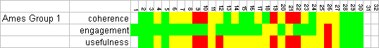
Overall scoring and heat map for Ames Group 1

Looking at the whole-session scores, the Overall score is lower than the highest-scoring group of the four Ames session (2.8), and lower than either Rutgers group, indicating some sort of trouble or difficulty during the session, although higher than the low-scoring Group 2. Particularly, the Coherence and Usefulness scores are low. Zooming in further, it is apparent from the heat map that timeslots 9-12, 19-22, and 26 contain some sort of anomaly or event that caused the coherence and usefulness scores to drop to the Low level.

This gives context for the finer-grained analysis of what happened in timeslots 17 through 24, the trajectory of a complete “sensemaking episode” starting with a trigger and ending with the resolution.

The CEU graph shows the drop in Coherence (blue) and Usefulness (yellow) as the mapper struggles to get back on track during the sensemaking moment.

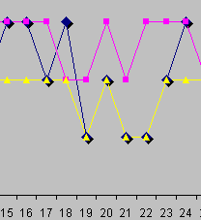
CEU Graph for sensemaking episode

The full CEU grid provides further detail on what occurred and the CEU ratings in each timeslot:

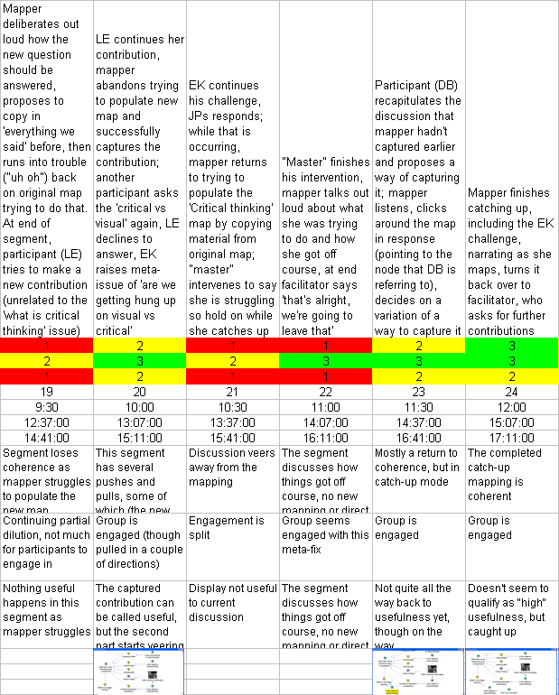
Screenshots when display had changed significantly
Usefulness descriptions
Engagement descriptions
Coherence descriptions for each timeslot
Absolute and relative timing (bottom two rows are timings from Camtasia and video recordings)
CEU ratings for each timeslot
General descriptions of the activities in that timeslot
Full CEU Grid for sensemaking episode

Narrative description of the sensemaking episode

The instance occurred for about 2.5 minutes of the 24 minute session, starting at 13:36 (TS17) and lasting until 16:58 (TS23). The facilitating team had constructed a knowledge map with some seed questions that they asked participants to provide answers to (which they in turn added to the knowledge map displayed to all on a large screen in front of the room). One member of the team acted as the mapper. The session had proceeded more or less as expected until at 13:36 one participant (P1) began to challenge some of the contributions to the overall discussion, questioning why some participants kept asking if others’ contributions counted as ‘critical thinking’ or ‘visual thinking’.

(Note: The pattern that emerged during the sensemaking episode had root even in the first few seconds of the session, when a participant offered “Considering alternative perspectives” as one of the answers to the seed question, and another participant said “Would that be a sub-class of critical thinking?”)

The challenge did not fit into the planned flow of events, and the mapper, who up to that point had been able to capture participant contributions into the map quite fluidly, lost her way. She began trying to map P1’s challenge at 13:49. At 14:42 she was in the midst of doing this when another participant (P2) made a new verbal contribution that did not reference the challenge.

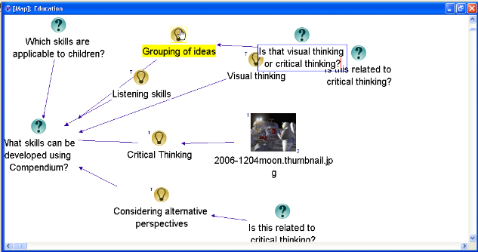
Figure 1: Map at 13:36

A third participant, P3, asked if P2’s comment counted as ‘critical thinking’ or ‘visual thinking’, prompting a further challenge from P1. The mapper was able to capture P2’s 14:42 contribution on the fly, but couldn’t map either P3’s question or P1’s new challenge. The interchange is shown here:

Time mm:ss | Dialogue/action
14:42 | (P2) “I think another skill that can be developed … is the ability to see bigger questions”
14:51 | (P3) “Is that not also part of critical thinking?”
14:53 | (P2) ““Uh it may or may not be but I … that's my opinion.”
15:03 | (P1) “… why, why is it important… we seem to be getting caught up into but isn't that critical thinking, isn't that critical thinking. Why is that important? I mean, why is it important that we relate all these things to critical thinking.”
In the course of this, the mapper got so far behind in mapping P1’s challenge that she became stymied. This can be characterized as the sensemaking instance.

There are really two overlapping dilemmas. Firstly the participants’ issue about how to frame the conversation itself, and secondly the mapper’s attempt to regain her momentum and resume making coherent additions to the map. In this case, after some further back and forth among the participants, a fourth participant (P4) contributes a possible solution:

15:33 | (P4) “OK... so I would now interrupt, as a facilitator I would interrupt, because I see, um, [the mapper], struggling with keeping up… OK so I would say ‘hold that thought’, let her just finish this for a moment… and then repeat your question so we can capture it.”
15:53 | (Mapper) “Um… yeah so I did, I wasn't able to capture the stuff that went into the 'What is critical thinking' and that's where I'm behind, I'm trying to copy.”

After some negotiation about how much time was left in the session, the mapper asked the room for help in deciding what should be put onto the map. A fifth participant (P5) provided a helpful summary and suggestion for how to represent the discussion:

16:09 | (Mapper) “OK. So what's the current thing I'm trying to capture”
16:11 | (P5) “But [P2] said … she thought one of the issues was the ability to see bigger questions, was something…”
16:18 | (Mapper) “Right, so how would I do that…”
16:20 | (P5) “...and then somebody said… isn't this just part of critical thinking so if I was mapping that I'd just put a minus there… and say isn't this just, you know, this is part of, should be part of critical thinking and then I'd put another question mark off that and say why is this important”

From that point until the end of the episode at 16:58, the mapper executed a rapid series of moves on the map, which are summarized here:

16:26 | Moved cursor all the way to right side of the screen very briefly, then back to hover over 'Considering alternative perspectives' then 'Ability to see bigger questions' then down to bottom of window in response to P5’s comments
16:35 | Moved the new cloned node to under 'Ability to see bigger questions'
16:41 | Linked cloned node to 'Ability to see bigger questions'
16:42 | Highlighted the clone
16:45 | Keyboard-created new Idea node linked to the Question, gave it the label “Why is this important?”
16:52 | Moved node down and to the right slightly
16:54 | Moved cursor out of the way over to the right
16:55 | Moved 'Is this related to critical thinking' down and to the right slightly (for appearance)
This enabled her to bring the map up to the point where it corresponded to the summary provided by participant P5 (see Figure 2), and to announce at 16:58, “I’m caught up.”
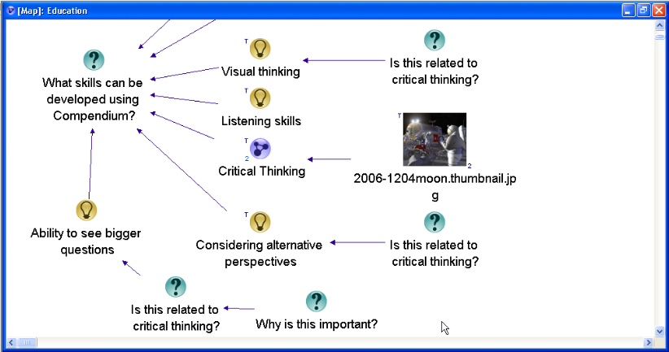
Map at 16:55

Framing the moves and choices

In this excerpt we see the mapper confronted with a breach in the expected chain of events, resulting in a sensemaking instance. This was caused by an escalating series of challenges and interruptions among the participants that caused the mapper to lose her place.

In the excerpt, we see improvised actions that draw on practitioner (as well as participant) repertoires. Up to the point of the breach in TS19, the mapper had followed a straightforward, pre-planned “dialogue mapping” approach in her work on the knowledge map. When things went wrong, this had to be (temporarily) abandoned. With the help of several of the participants, the mapper was able recast the situation, which helped her launch a rapid series of actions on the map to bring it back to a point where forward progress, and the dialogue mapping technique, could resume.

Element | Descriptive and normative questions
(A.1) Imposing their own coherence and values on a situation | - What coherence is the practitioner imposing on the situation?  There were two flavors of imposed coherence: a ‘clean’ discussion map, and attempts to keep the display coherent in the face of divergent and somewhat problematic contributions (in the sense of, hard to fit in, tending to pull the discussion off the intended course) – there was a concerted attempt at coming up with coherent structures on the fly to encompass both the “primary” contributions (the answers to the seed questions) and the “meta” contributions about visual vs critical thinking.  - What values is the practitioner imposing on the situation?  There was a value of inclusiveness, of trying to map everything offered, but a willingness to set some possible directions aside in the interest of cleanly mapping some of the contributions.  - In what ways are these congruent (or not) with those of the participants?  The mapper had to choose between following all of the possible threads – particularly the pull toward the meta-questions about critical thinking – that some of the participants wanted to pursue, vs. focusing on cleanly mapping a few. Of necessity some participants’ interests got shorter shrift as a result.
(A.2) Constructing narratives to account for how the situation arrived at the current pass / breaches in canonicity | - What is the narrative the practitioner is using to construct the situation?  There is a discussion that emerges “naturally” from the seed questions, but the breach comes in that the discussion is not following the intended form cleanly.… I am going along capturing the discussion as it happened, but then divergent input comes in which requires operations that a) I’m not quick enough at doing, or b) don’t seem to fit right.  - What is its degree of internal consistency?  - How evocative and inclusive is it?  The pre-planned, intended narrative sets up a canonicity of a cleanly unfolding discussion, tagged answers with images in response to the clear questions. However the answers start spawning a meta-discussion that breaks down, and the practitioners were not able to be completely inclusive of all the contributions.  - How useful is it?  The usefulness of the intended narrative breaks down in the face of the discussion that was spawned. However with the various actions and interventions, an equilibrium is restored and canonicity resumes more or less according to the intentions.
(A.3) Eliminating prejudices and preconceptions | - What prejudices may be active?  - What preconceptions may be active?  Other than the prejudice/preconception that IBIS-style discussions will unfold cleanly, the level of prejudice/preconception seems low.  - What personal desires or goals may be active?  The mapper and facilitator seemed genuinely interested in being generative and inclusive, but also willing to intervene to keep things coherent.
(A.4) Personal authenticity in the practice setting | - In what ways is the practitioner acting in an authentic manner (vs. received, affected, etc.)?  Neither mapper nor facilitator appeared to be acting in an inauthentic manner.
(A.5) Mediated objects and other interventions should preserve openness and dialogicity | - How do the representations the practitioner constructs or modifies foster openness and dialogicity?  The seed questions were appropriately open-ended. The question nodes added during the session were partially so, though some were phrased as yes-or-no questions which are less open. These were mostly done quickly in response to the meta-questions which were difficult to handle by their nature (“is this visual or critical thinking”, “why do we keep getting hung up on this question”, etc.), but by deciding (after some back-and-forth) to add these questions onto each answer they pertained to, the practitioners were preserving the opportunity to deal with the meta-questions later, recording them in answer to the concerns of some of the participants, while still keeping the intended discussion course going. A similar dynamic was gainged by following the suggestion to open a separate map to address the meta-question “what is critical thinking”, which left the possibility of later exploring that question open.  - How do they inhibit them?  By not explicitly following the pull to address the meta-questions, some openness (following any conversational thread) was sacrificed.
(A.6) Artifacts should be clear, expressive, and helpful | - How clear are the artifacts produced/modified by the practitioner?  The seed question and maps were clear enough to generate active discussion along the intended course. However, the image aspect was not followed, at least in part because it was not clear how or why the participants were to choose images that aligned with their answers to the seed question. The map contents generated during the session itself stayed clear except when the mapper fell behind, generating the repair activities.  - How expressive are they?  By using open-ended questions to seed the discussion, and by capturing and succinctly mapping most of the participant contributions, the practitioners created a reasonably expressive map (in the sense that one cal look at it afterward and get a good sense of what was discussed and what it meant; the map is easy to follow).  - How helpful are they within the context of practice?  Except for the somewhat confusing mapping of the meta-questions about visual vs critical thinking, the practitioners’ structures appeared to help guide, record, and contain the discussion in a useful manner.
(A.7) Perseverance in the face of checks and resistance | - What checks to forward progress does the practitioner encounter?  The main check to progress is in the divergent meta-questions that are asked, and in the struggle to find a way to map them without falling behind.  - What resistance from participants, materials, etc. occurs?  There is resistance in the difficulty of finding a way to map the meta-questions; in the question of repeating the “is this critical thinking” question via cloning vs attaching the same node to multiple answers; in the on-the-fly creation of a separate “What is critical thinking” map. All are resistance of being able to quickly and cleanly map inherently complex and/or confusing contributions from participants, that seem to fly off in different directions, keeping them neatly within a single container/structure. There is also a form of resistance in not being able to remember and mentally stack up all the offered contributions – too much input coming in too fast, then trying to remember it all while performing unrelated actions.  - How does the practitioner respond in the face of these?  There are several kinds of responses: on-the-fly unspoken decisions about how to map; brief negotiations on how to proceed; direct interventions from facilitator not to follow a certain line of inquiry in the face of lack of time; direct (and followed) suggestions on how to map; appeals (which were answered) to remind the mapper of who had said what so it could be added to the map in the catch-up phase.
(A.8) ) Clear and focused communication | - How clear is the practitioner's verbal communication?  Both mapper and facilitator were very clear in their verbal communication.  - In what ways does the practitioner maintain focus on the aspects of importance in the situation?  Both mapper and facilitator verbally intervened in various ways when things ran off the rails, came too much too fast, or when decisions needed to be made to follow a line of inquiry or not; or when needing help from the participants to catch up. These came in the form of verbal statements or questions for the most part. There were also points when the mapper combined talking about nodes with pointing at the nodes in questions, interweaving her manipulations and operations on the map with narration and/or questioning of what to add or how to proceed.
(B.1) The importance of participants' impulses and desires; attention to what may be bothering or affecting participants | - What observable or discoverable participant impulses, desires, or other factors are operating in the situation?  There is the impulse to “go meta” and ask the meta-questions about visual/critical thinking, as well as the impulse to intervene in the shaping of the map itself, offer suggestions for how to proceed, how to link or clone, what should be new maps, etc..  - How does the practitioner address these?  The mapper and the facilitator each attempt to respond and include as many of these as they can within the boundaries of the session and their desire to keep it at least partially on track. They ask clarifying questions, and make attempts to accommodate.
(B.2) Unfinalizability; preserve room for surprise, imagination, and creativity to emerge | - In what ways do the practitioner's actions reflect an attitude of unfinalizability toward the participants and their interests, concerns, and agency?  In general both mapper and facilitator keep things open-ended and generative in their verbal statements and questions, their tone, their attempts to be inclusive, and the way things are mapped (questions are kept more or less open-ended, etc., issues are captured as questions rather than closing off as ideas or pros/cons – even at one point a participant suggests mapping something as a con, but the mapper puts it as a question instead.  - In what ways does the practitioner preserve or close off room for surprise, imagination, and creativity to emerge?  There is nothing in the practitioners’ actions that close things off per se, except for the facilitator’s intervention not to pursue the “what is critical thinking” map, and the mapper’s decisions to forego some shaping suggestions in the interest of consistency and moving forward.
(B.3) Dialogic orientation | - How do the practitioner's actions and communication open up or close off dialogue in the situation?  - In what ways does the practitioner display openness and sensitivity to the different participant voices (vs. summarizing them into abstractions or types)?  There was no discernible summarizing into abstractions or types during this session. Although one of the participants was raising objections to the meta-questioning and that could have devolved into this, the practitioners avoided doing so. Instead by doing their best to capture and include all the levels (direct contributions to the seed questions, meta-questions, and the challenge to the meta-questions), they seemed to be open and sensitive to the different kinds of input and concerns. The only closing-off came in the facilitator intervention to close off adding to the “what is critical thinking” map in the interest of time.
(C.1) Heightened degree of connection between people, setting, purpose, and medium | - How do the practitioner's actions help create this kind of connection and integration?  I would not say there was a demonstrable heightened degree of connection within this short session.  - In what ways are the distinctions or boundaries between people, setting, objects, etc. made stronger or lesser?  It is possible that, had the session continued, some interesting exploration of the connections between the meta-questions and challenge could have occurred. The way these were captured and mapped left the possibility open.
(C.2) High level and quality of communication | - How does the practitioner elevate (or diminish) the level and quality of communication in the practice setting?  For this session, this seems very tied to the issue of openness discussed above. By keeping things open and inclusively capturing and mapping, the discussion perhaps has a higher level of interchange – certainly as it is reflected in the map itself – than some others. However I wouldn’t say there was overall a particularly high level of communication as a whole. Instead, what can be said is that the practitioners kept it from devolving in response to the various pushes and pulls by virtue of their actions.
(C.3) Importance of the past as the background and context to the practice setting | - In what ways does the practitioner reference or bring in elements of past work, ideas, or events?  - Are such "background" elements combined with "foreground" (current) concerns, ideas, or representations?  Except for the provision of the prepared map itself, there was little reference to past elements within this session.  .
(C.4) The relationships of parts to parts and to the whole | - How does the practitioner focus on both individual details and the relationships of those details to the 'big picture' and each other?  There was quite a bit of having to move between parts and parts, and parts to whole in this session, demonstrated especially by the attempts to link the meta-questions to the other responses, and to gather materials to populate the “what is critical thinking” map. Indeed much of the sensemaking instance involved this movement back and forth, and trying to glue the three levels of discourse together. Each participant statement, in effect, had to be rapidly evaluated for how and where it fit with the various levels, as well as (later in the session), the two seed questions. There are a variety of transitions, so to speak, that occur. Some of these are spurred by “master” participant suggestions about how the various levels of discourse can be mapped. Some occur from the mapper’s verbal narration of what she is trying to do or having trouble with, which contain references to other parts of the session. The challenge question itself was a movement from parts to whole – the participant was, in effect, questioning the health of the session by asking why the meta-questions kept coming up. It was in trying to balance all these and come up with map content and structure for all in a compressed period of time that things went off track during the sensemaking instance.  - How are the moves from parts to whole accomplished?  These happen more or less as responses to participant contributions. For example, when the challenge comes, the mapper goes along with it and tries to map it.

